**Story Keeper  
The journal of Heroes**

Tristan Barajas(Project Manager)  
Christian Boyd(Lead designer)  
Tristan Willis(Tabletop RPG specialist)

**3. Problem and Solution Overview**

**Problem**

It takes a long time to sort through a lot of notes during a D&D game which breaks up the action while someone is searching through looking for an important detail.

**Proposed solution:**

The solution we came up with after all the sketches and testing is an desktop/tablet app with tab-based organization to make sorting notes faster, as well as a voice-to-text game log to completely eliminate the need to write notes at all. Though many users would still prefer to take their own notes, so our solution supports that as well.

**4. Initial Paper Prototype and Tasks**

# **Overview picture:**

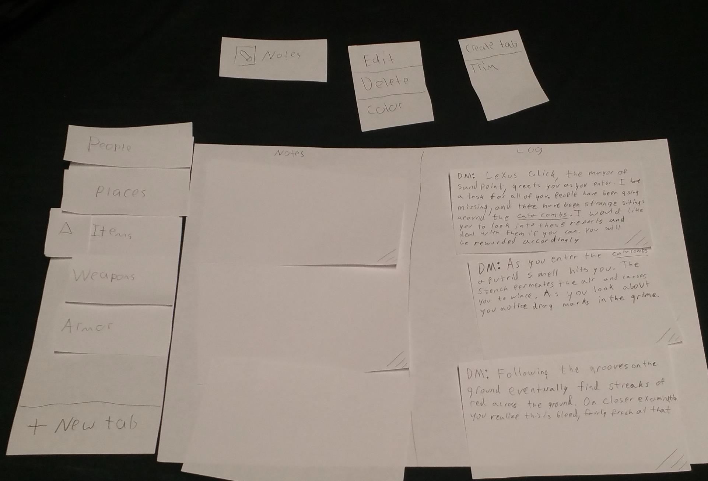

**Task 1:**

For this task, the user will create a note (or notes) by writing It on a small section of paper. They will then drag the note to the corresponding tab to store a copy there.

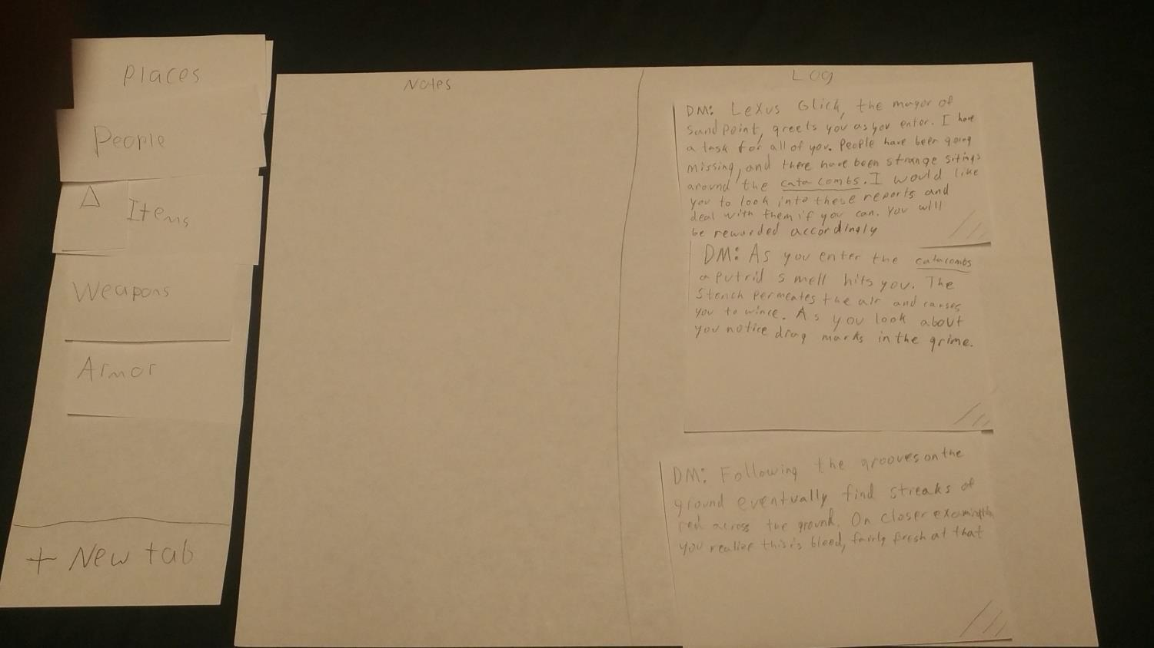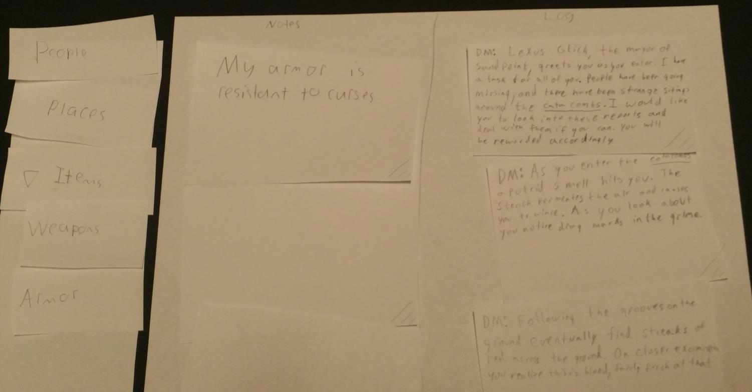

First, the user writes a note that they need stored for future use.

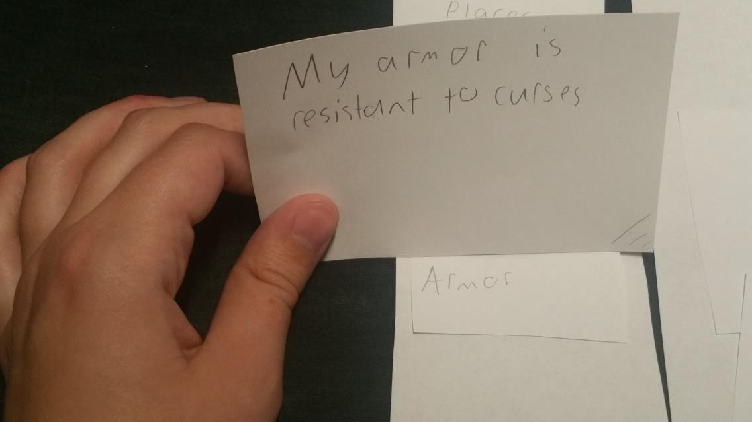

Next, the user drags the note to the tab they would like to store it in

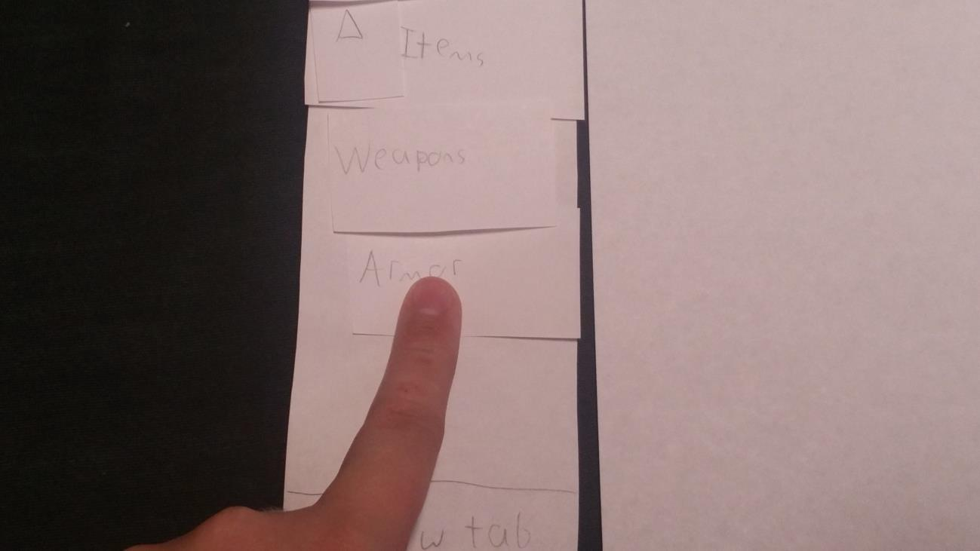

Then they click the tab they just dragged to and…

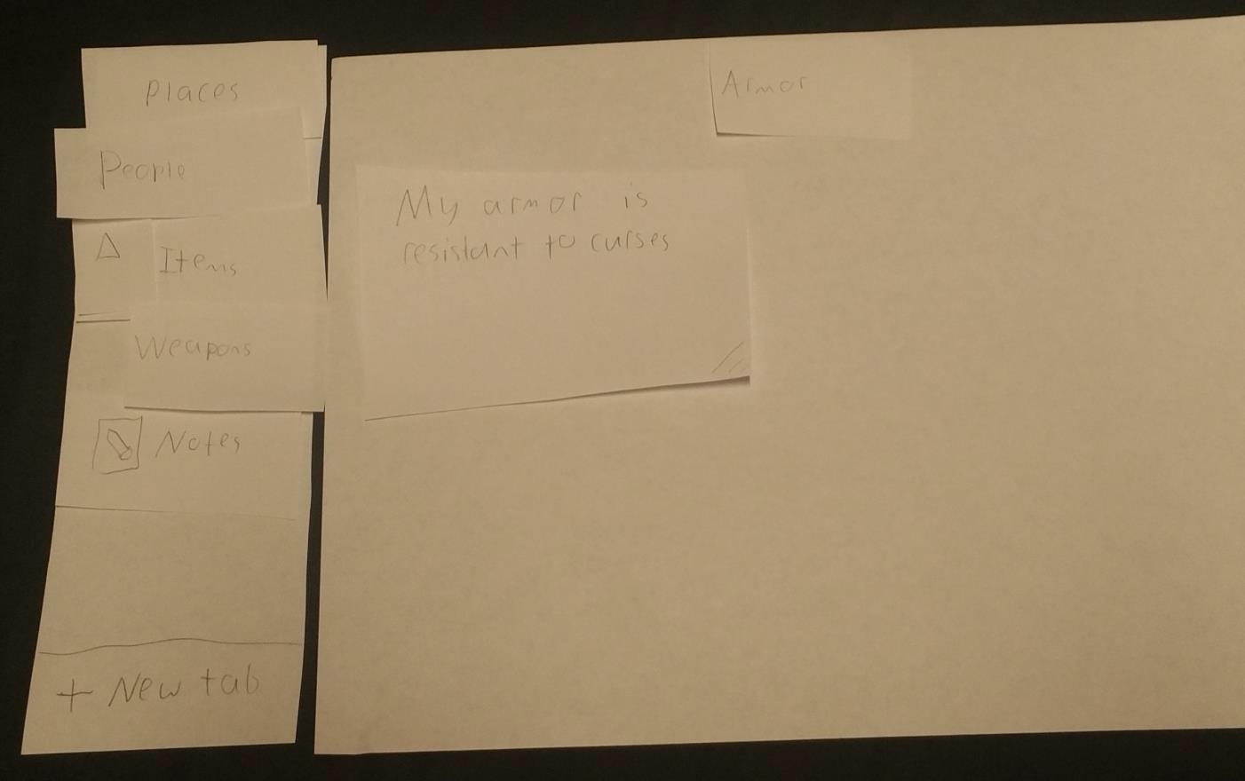

There’s the note!

**Task 2:**

For this task, the user will search and gather notes by term, simply by creating a tab.

First the user creates a new tab.

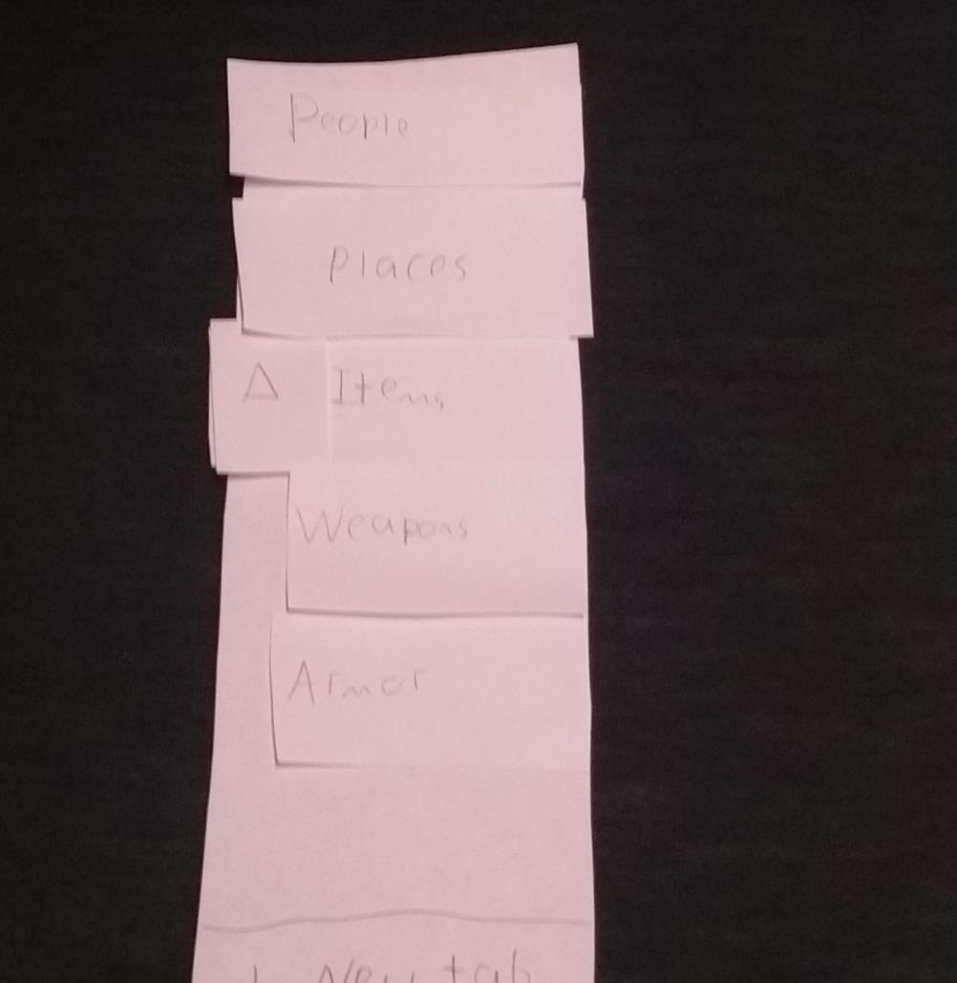

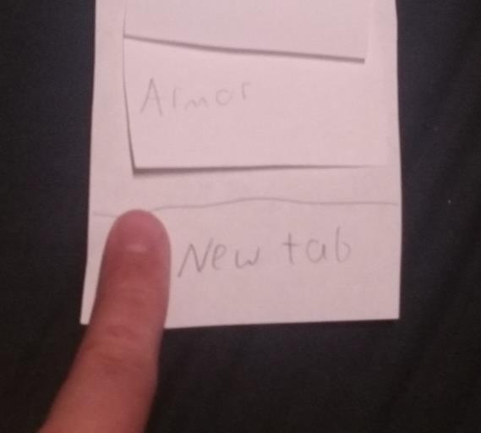

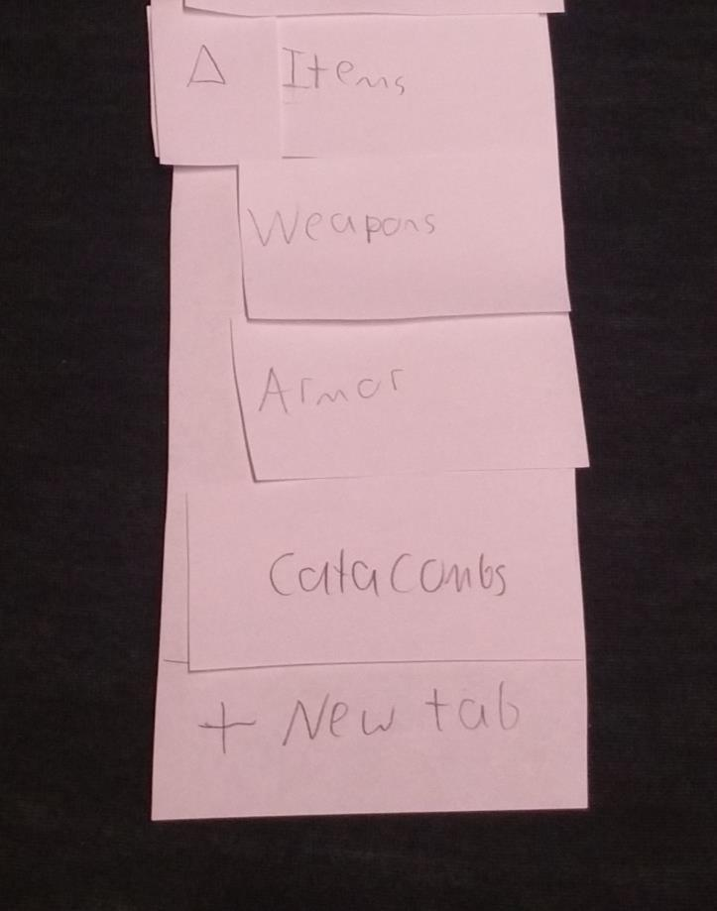

In this example user has decides to keep track of “Catacombs”

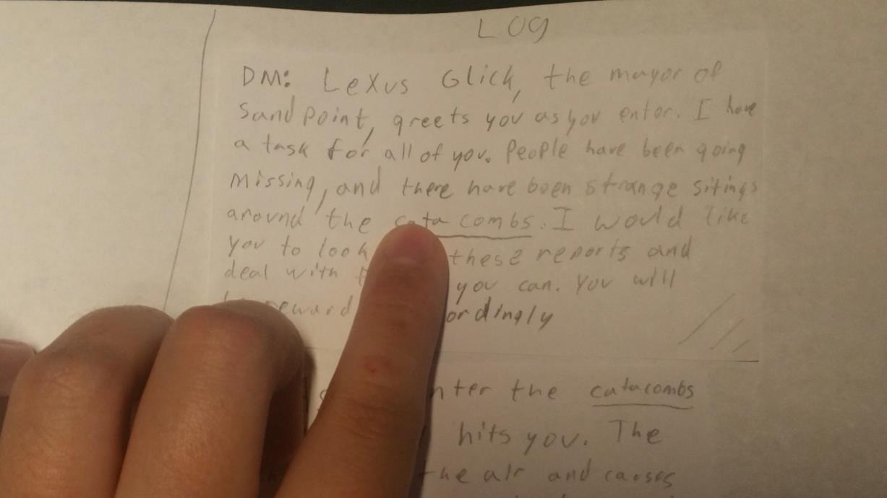

When a new tab is created, direct mentions of the tab’s name automatically get hyperlinked in all notes.

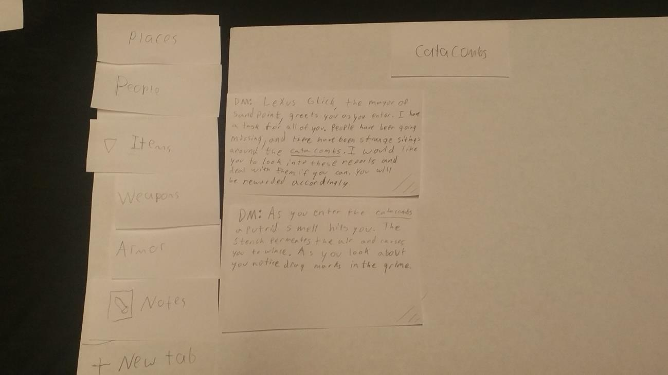

And all notes containing a direct reference to the tab get automatically added.

**5. Testing Process**

**Method:** Our testing started by doing an in-class heuristic review to iron out some easy to spot issues so that our usability tests were not wasted fixing issues that could have been more easily handled. During the heuristic review we realized some of our buttons were unclear and we were missing helpful things such as a help menu. After this we started our usability testing. During our first test we realized that our tasks were not specific enough and afterwards further specified the task so we tested the intended interactions. As usability testing progressed we changed many attributes about the design and attempted to make the interface more readable and user friendly.

**Usability Tests:** During the first usability test we performed the evaluation at the University of Utah. To make the environment as much like a play area as possible we found a properly sized table which has boxed off from other areas providing some privacy. During the first test we found we were not as prepared to execute the interactions required for testing and had a few hiccups. We discovered one catastrophic failure and then realized task 2 did not prompt the user to use the log feature as intended. We took this information, touched up the design and launched into the next two usability tests. During usability test two we realized that the draggable text boxes were continuing to be a problem so we tried to make it more clear that the boxes could be moved. From this point we touched up the design in areas we had seen lacking and moved on to our final test. During this test we had our improved task description and had added an animation/sound to the design to help illustrate what was going on during operation of the prototype.

**Participants:** Our participants were all University of Utah students and had varying amounts of knowledge of D&D. Each of our participants also were familiar with the types of digital interface we based our design off of. All participants provided good commentary of what was going through their mind, which helped with our information gathering.

**Roles:**

Tristian Barajas- Prototype Operator/ Task Prompter

Christian Boyd- Observer/ Note Taker/ Assistant Task Prompter

Tristian Willis- Design Consultant

**6. Testing Results**

**Heuristic review:**

These are issues that came out during our in-class heuristic review.

Issue #1:

* Record Button unclear. Ex. “What does it do?” “Does it record sound?” “Does it start the voice transcription?” “What is this button?”.
* Heuristic 2 violated: match between system and the real world.
* Severity: 2

Before: After:

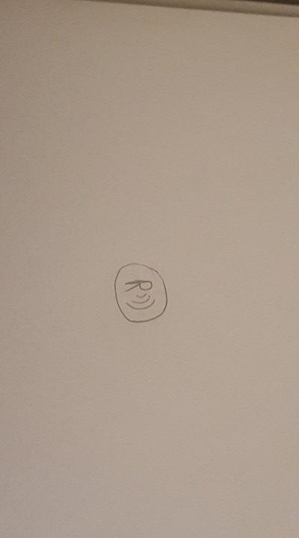 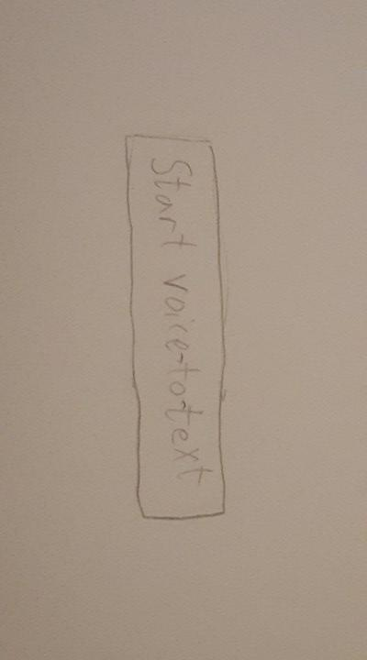

Issue #2:

* No help documentation.
* Heuristic 10 violated: Help and Documentation.
* Severity: 4

Before: No help features

After:

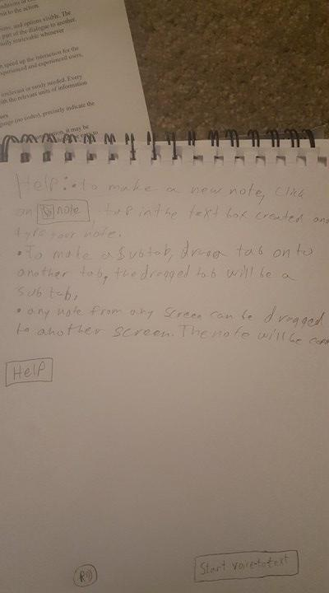

Issue #3:

* Could slim it down for phone
* Heuristic 3 violated: User control and freedom
* Severity: 1

Before:

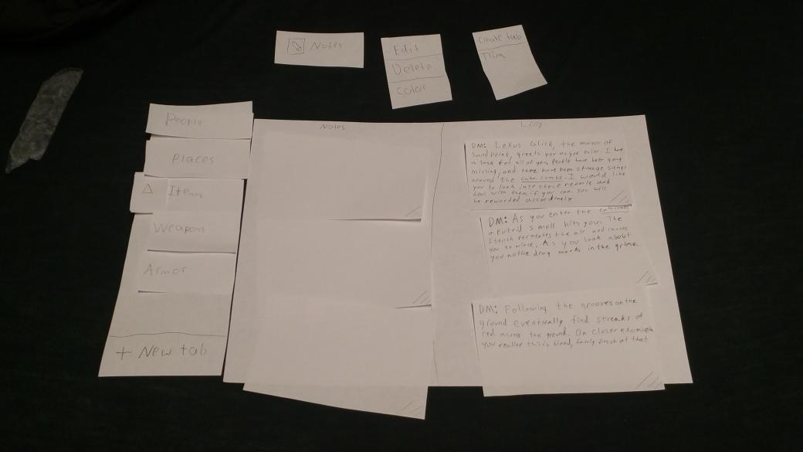

No changes made

**Usability test:**

We interviewed David, a University of Utah student who occasionally plays D&D with his family. He was a good choice because he was available and struggles with note taking in his own games. We did our test at a Hive table in the union both because it was a convenient space and it felt a bit like the proper environment for a table top RPG. Task 1 was to create a note and store it within a tab and task 2 was to receive information from the dungeon master and updated the information about the catacombs. During our tests we noticed that starting was a little daunting, but half way through the first task he seemed to be getting fairly comfortable with the structure of the application. During the first task we had a catastrophic failure when David failed to recognize that the note he had transferred had gone to the tab he intended. During the second task we had a failure of our task description, David completed the task but did so without exploring the features we had intended for him to use. We created a third task with changed wording so that we could see if there were issues with that feature.

Roles:

* Christian Boyd – Recorder/Note taker
* Tristian Barajas – Introduction/ simulation runner

Issue #1 – Not clear when notes are transferred.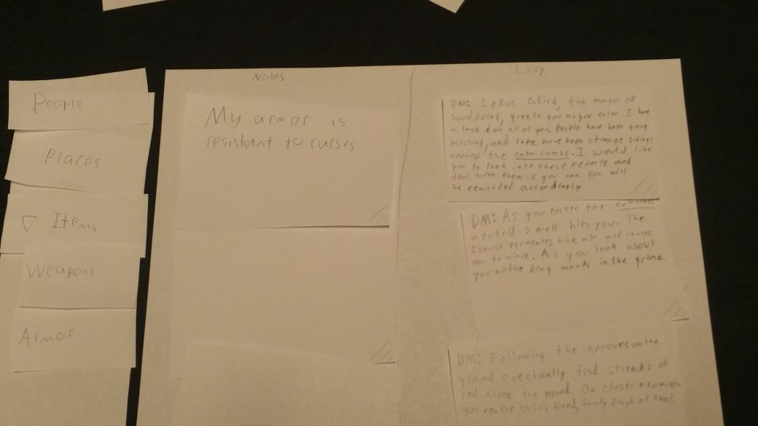

* When David moved his note onto the tab he had transferred it to, the current functionality was for the card to remain in place and a copy be moved into the tab. This might not have been an issue, but just prior to this he had tried to move the card into the log which was not permitted and the reaction from the system looked similar.
* Severity: 4
* We implemented a ‘sound effect’ to indicate that the note transfer was successful

Issue #2

* While executing task 2, David complete the whole task by creating a new tab, taking notes in the notes section and dragging the notes to the tab. This is objectively correct, but David never thought to use the log to make note taking faster.



* Severity: 2
* To remedy this issue, in future tests we explicitly forbid the participant from creating their own notes. This forces them to use the chat log to successfully complete task 2.

Issue #3

* A comment was brought up after our final task that subtabs would have been neat, unfortunately our design had dropdown tabs and the functionality was completely missed.

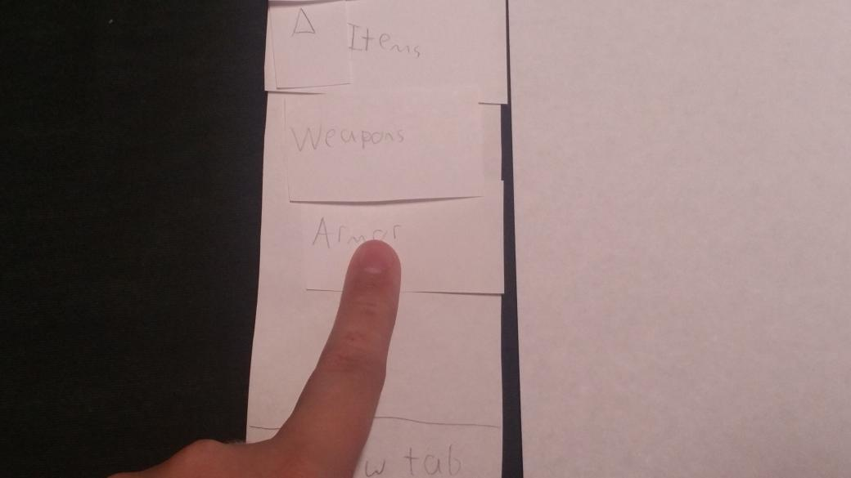

* Severity:3
* To try alleviate this issue we are changing to an alternate representation of dropdown menus, plusses and minuses.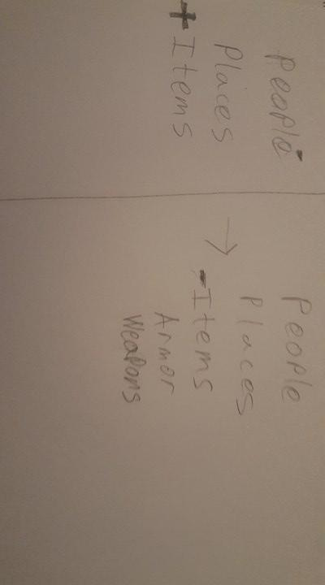

# **Usability test 2:**

We interviewed Sam, a University of Utah student who has plenty of friends that have played D&D and has seen games been played. He was a good choice because he was available and knew the structure of a typical D&D game. We did our test at a large table in the lassonde dorms because the tables of that dorm have frequently been used for D&D campaigns. Task 1 was to create a note, organize it, then view it and task 2 was to receive information from the DM, organize it, then view it. During the first task we had a catastrophic failure, as Sam didn’t realize that he could drag the tags, instead electing to copy the information, then paste it in a new note. This happened during task 2 as well, as he didn’t attempt to drag notes from the log. However, we didn’t consider this a separate failure.

Roles:

* Christian Boyd – Recorder/Note taker
* Tristan Barajas – Introduction/ simulation runner
* Issue #1
* During both task 1 and 2 Sam did not realize that they could drag notes or elements from the log. This caused a catastrophic failure in task 2, as Sam was unable to complete the task

. 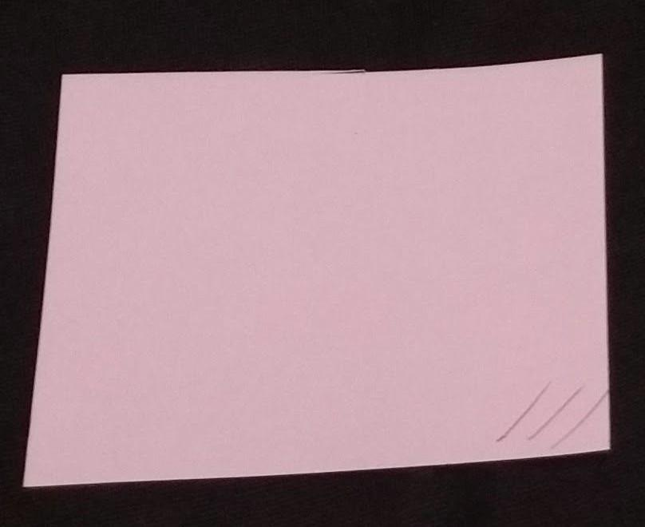

* Severity: 4
* As a result, we put the word ‘drag’ on the lower right corner, in addition to grip lines.

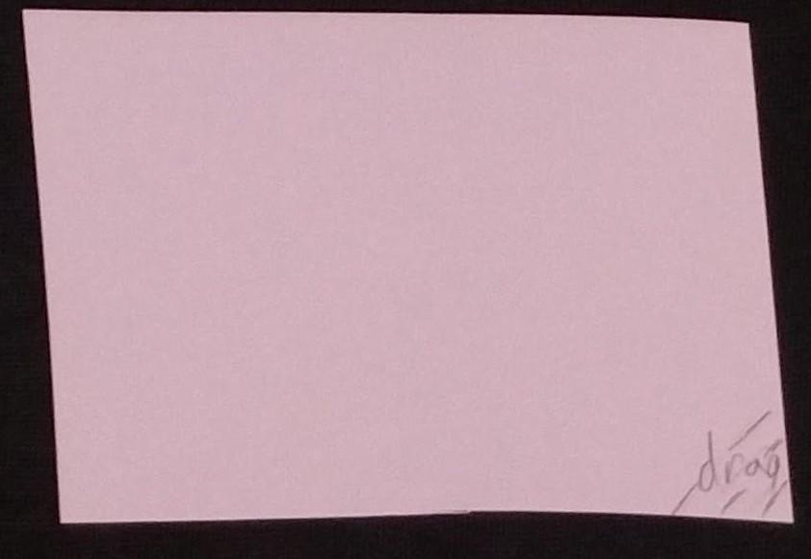

* Issue #2
* Sam was really unsure of what the ‘people’ tab was for at first. And clicking on it offered only a blank area (since no notes had been moved there yet)
* 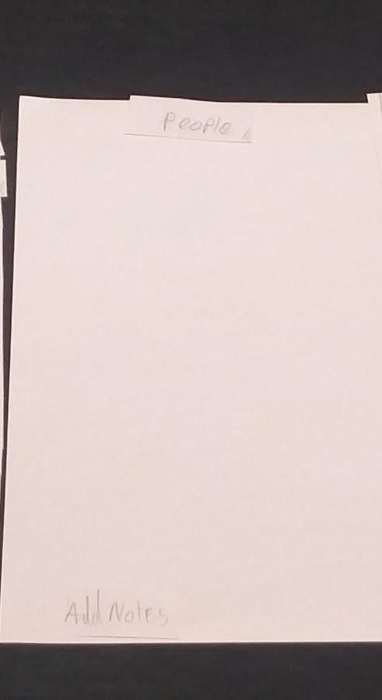
* Severity: 1

As a result, there is now a popup that states the purpose of the tabs. This popup only appears if the user opens a tab that’s empty.

● 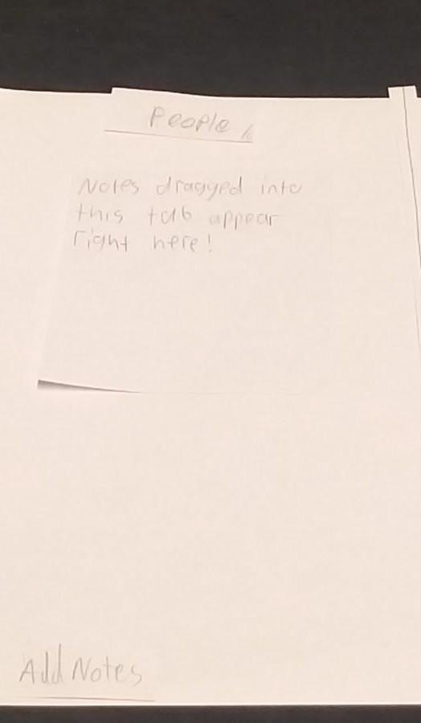

* Issue #3

There was no back button on our help page

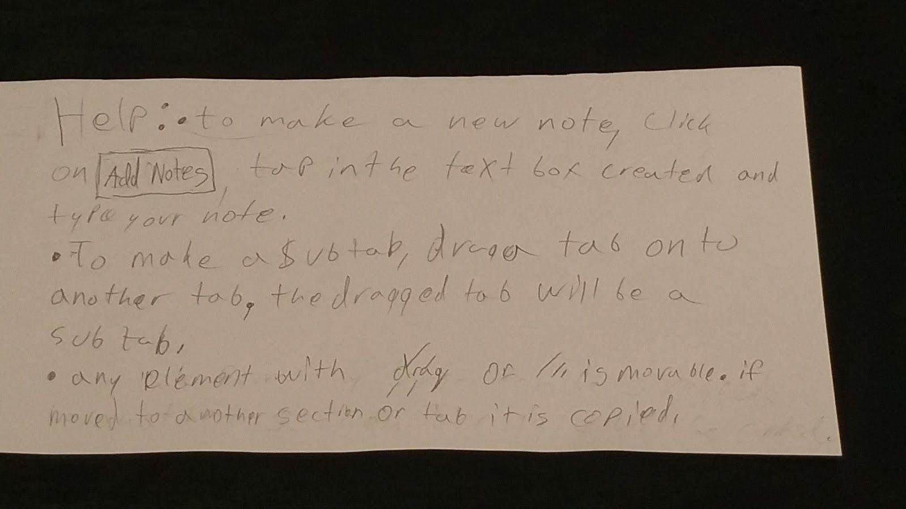

* Severity: 1

There is now a back button on the help page.

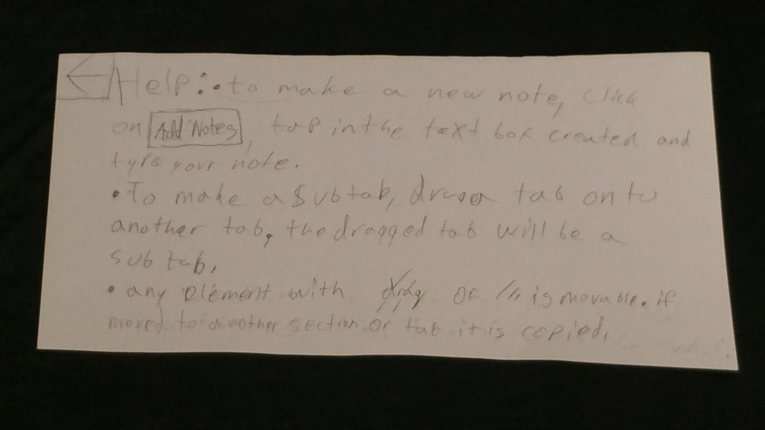

# **Usability test 3:**

We interviewed Jack, a University of Utah student who has a basic knowledge of D&D but no real experience with the game. We chose him because we want a good variety of participants, and to test if the design was universal enough for those outside the target demographic to understand. We did our test at a large desk in the CADE lab because we were curious to see how well the design could be used in a more distracted environment. Task 1 was to create a note, organize it, then view it and task 2 was to receive information from the DM, organize it, then view it. Jack’s immediate instincts were to look at the help menu, which gave helped him easily complete most of the tasks. However, we ran into some familiar issues with feature recognition. Roles:

* Christian Boyd – Recorder/Note taker
* Tristan Barajas – Introduction/ simulation runner
* Issue #1
* During task 1, Jack did not realize that he had to view the note after moving it. We had assumed that participants would naturally try to view the tab that they had placed a note in.
* Severity: 4
* For this, we did not change our design, but have changed the task to explicitly state to view the note in its new location.
* Issue #2
* When Jack moved a note onto a tab we made a ‘swoop’ sound and put the note back. We were hoping to convey that the note had been copied into a tab, but instead he assumed nothing had happened, and that he wasn’t allowed to move the note there. We had to tell him to check the tab

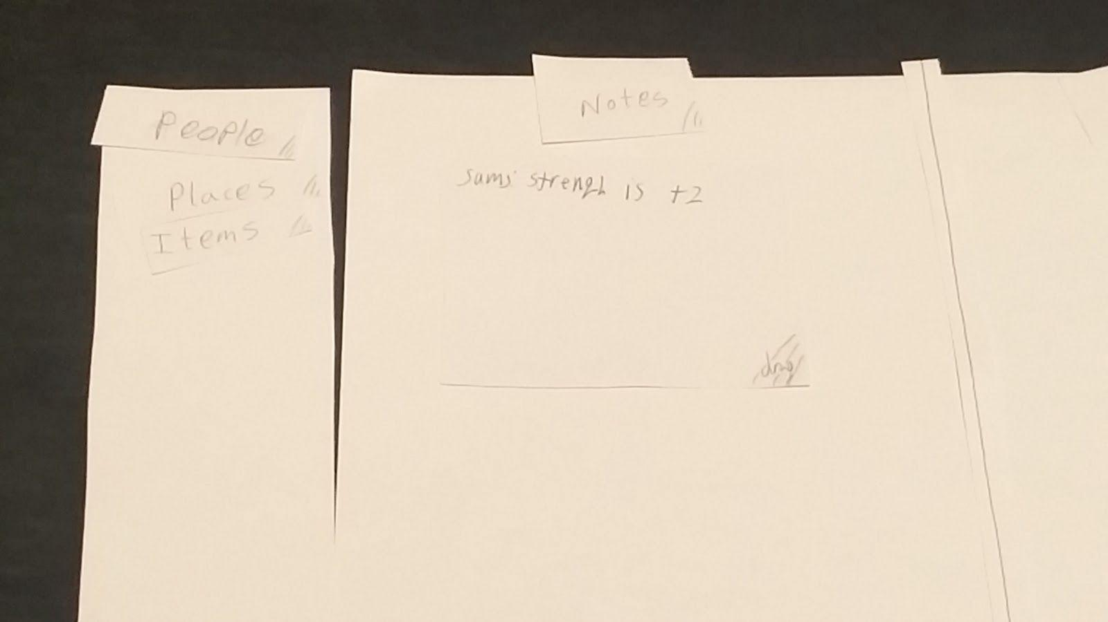

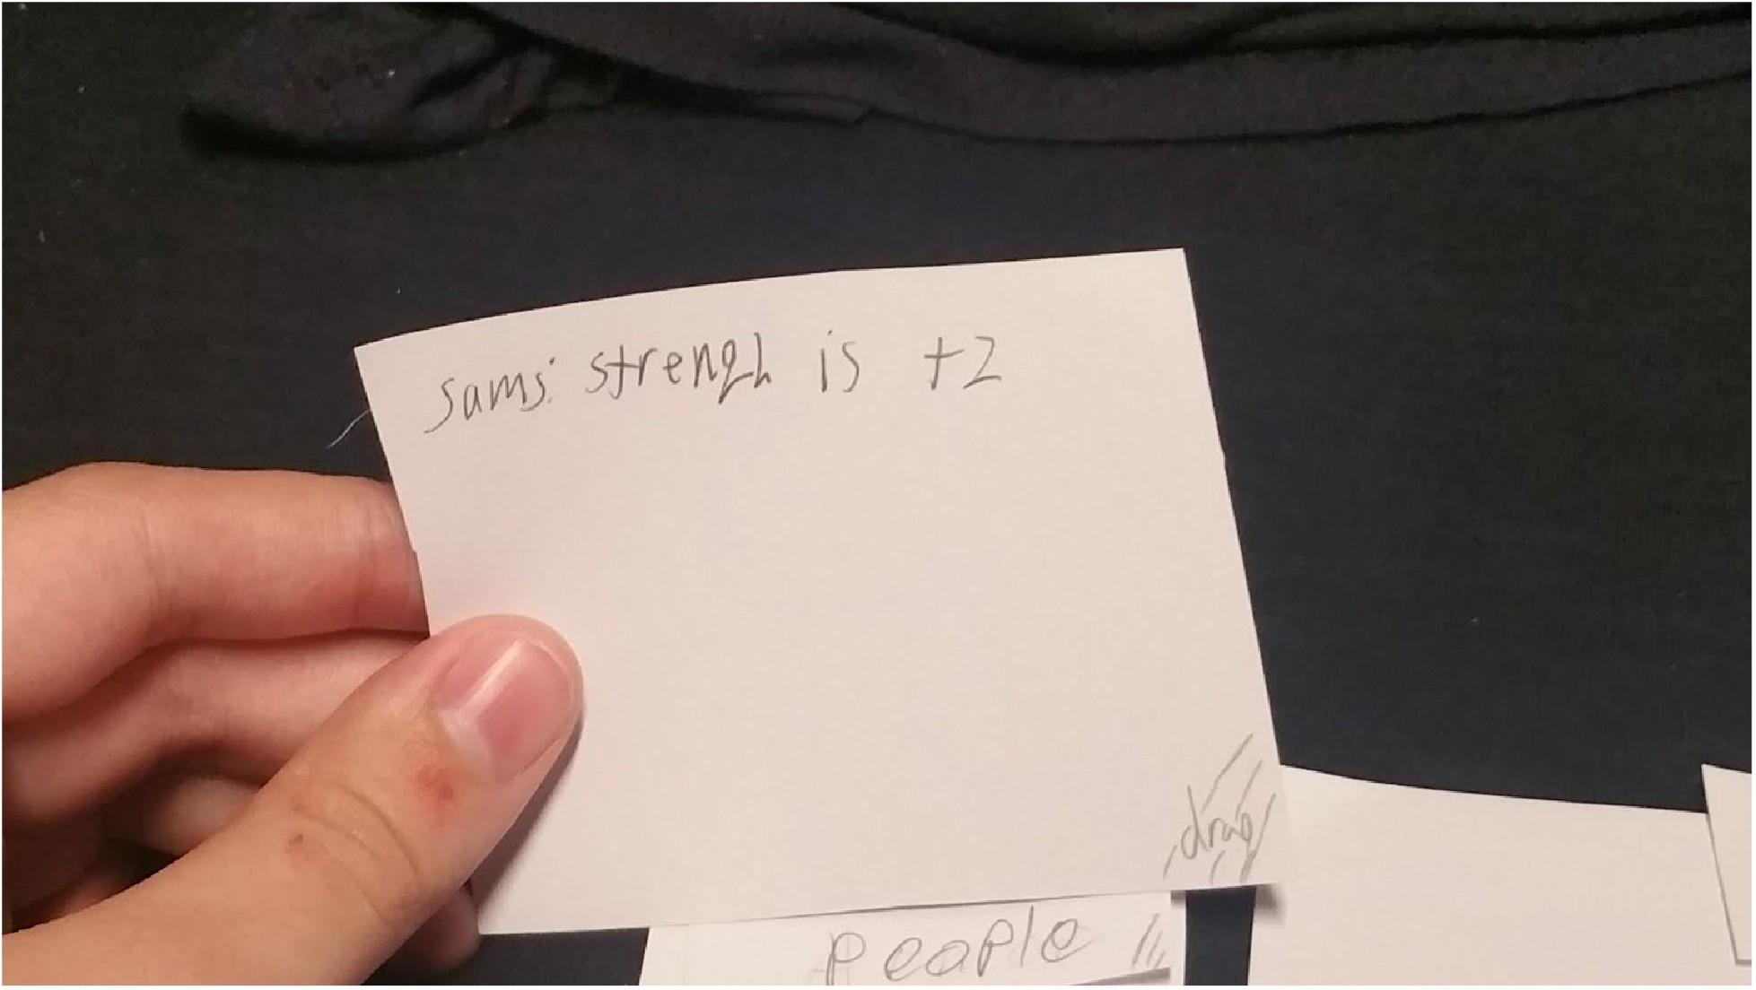



* Severity: 4
* As a result, notes are no longer copied by default, now disappearing from the tab they were originally located in (moving from one tab to another, rather than appearing in both). If a user wishes to copy a note, they will now have to right-click, select ‘copy’ then select a tab.

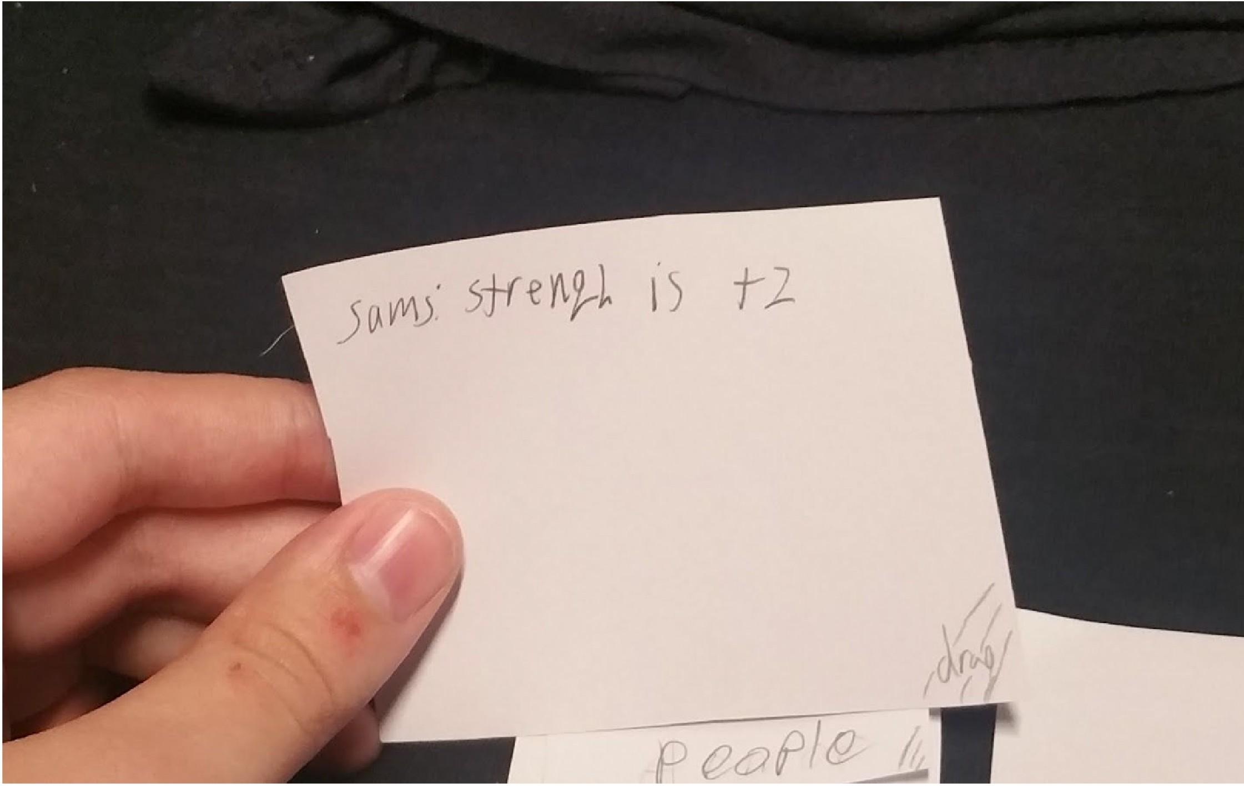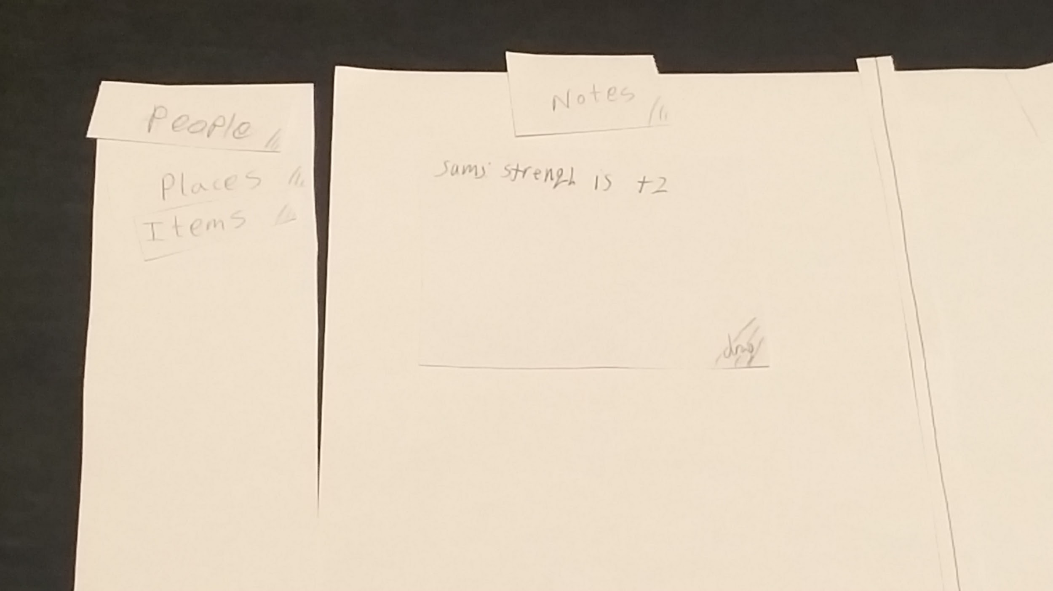

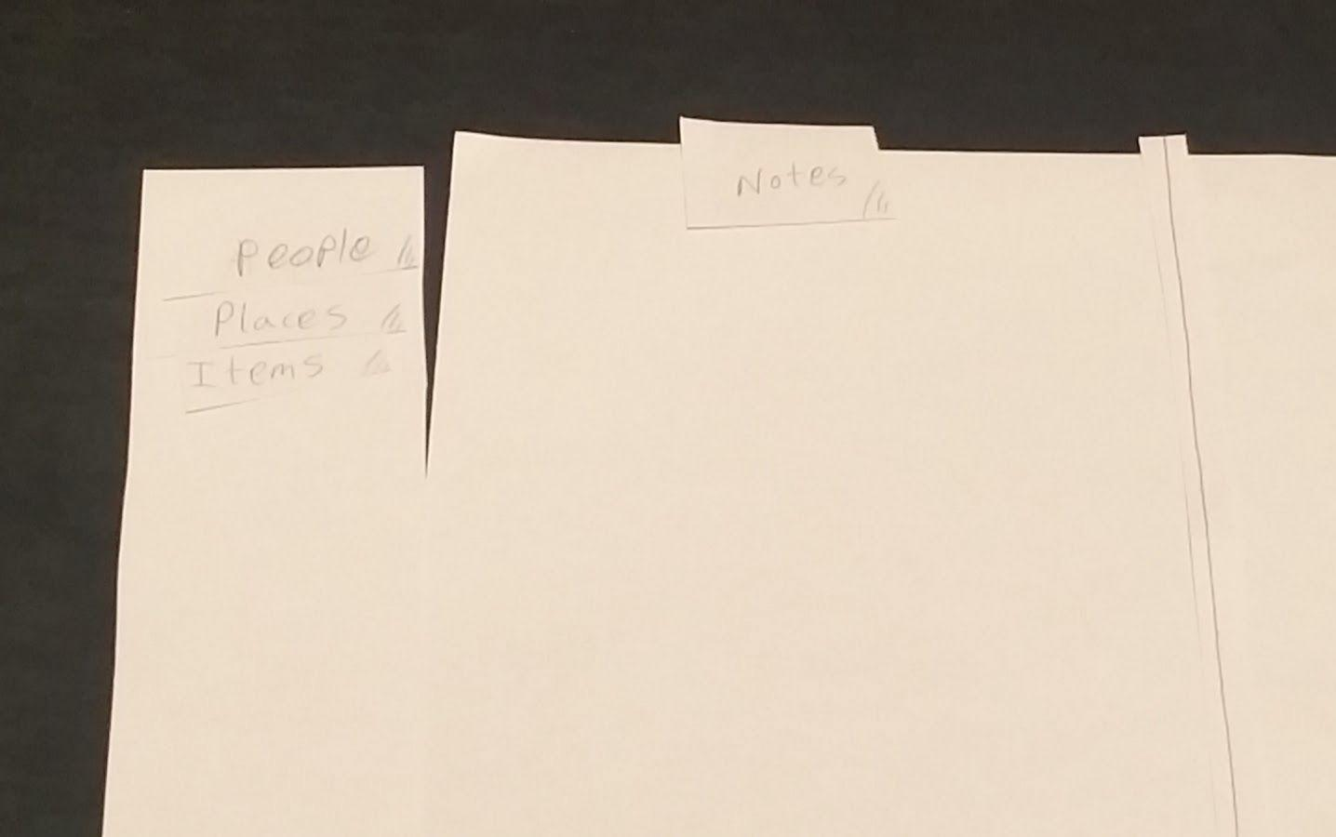

Additionaly, here is the change to the right-click

before:

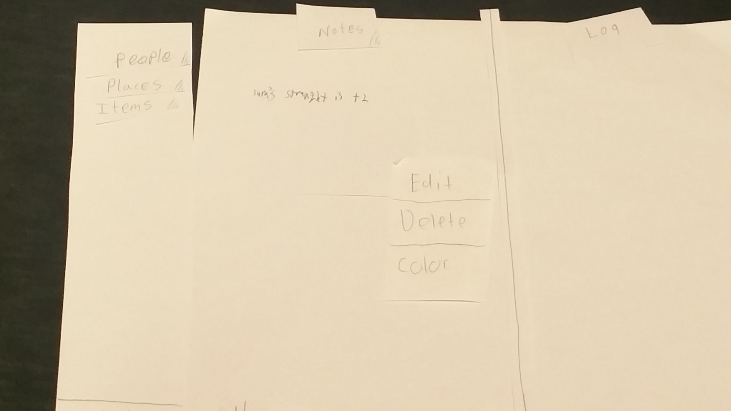

After:

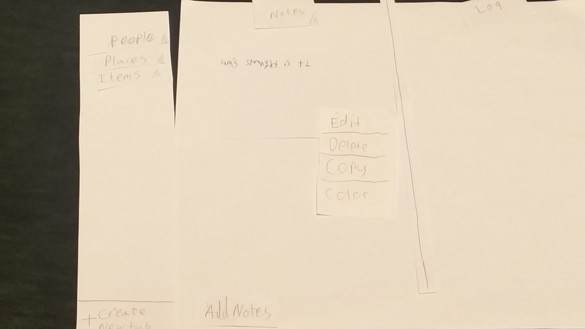

**7. Final Design**

**Overview:**

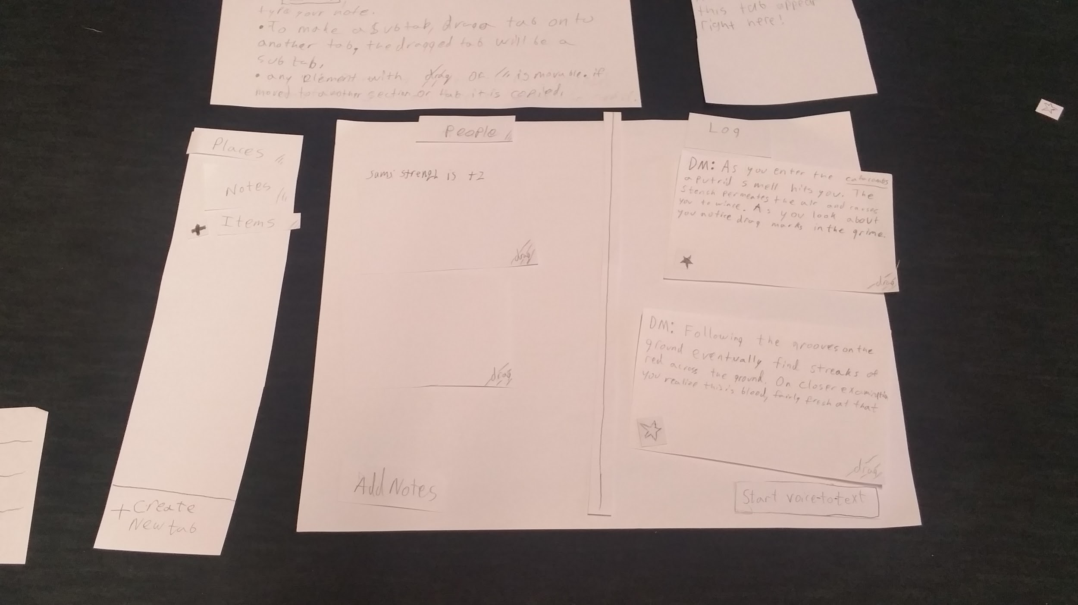

**Task 1: Writing and storing a note:**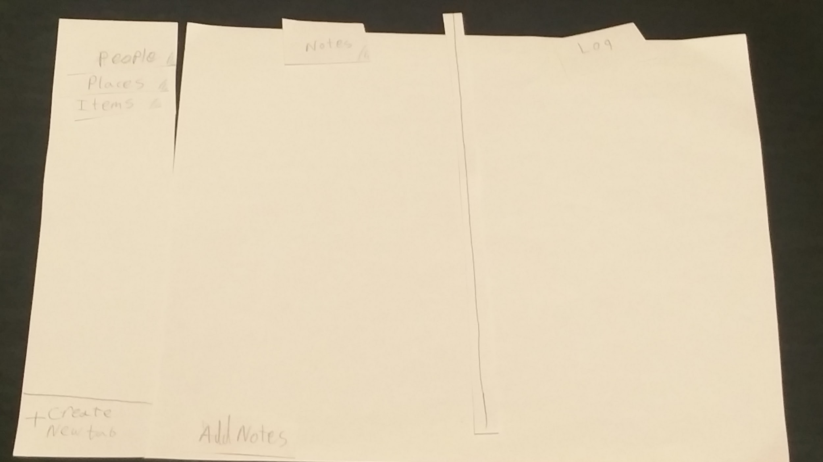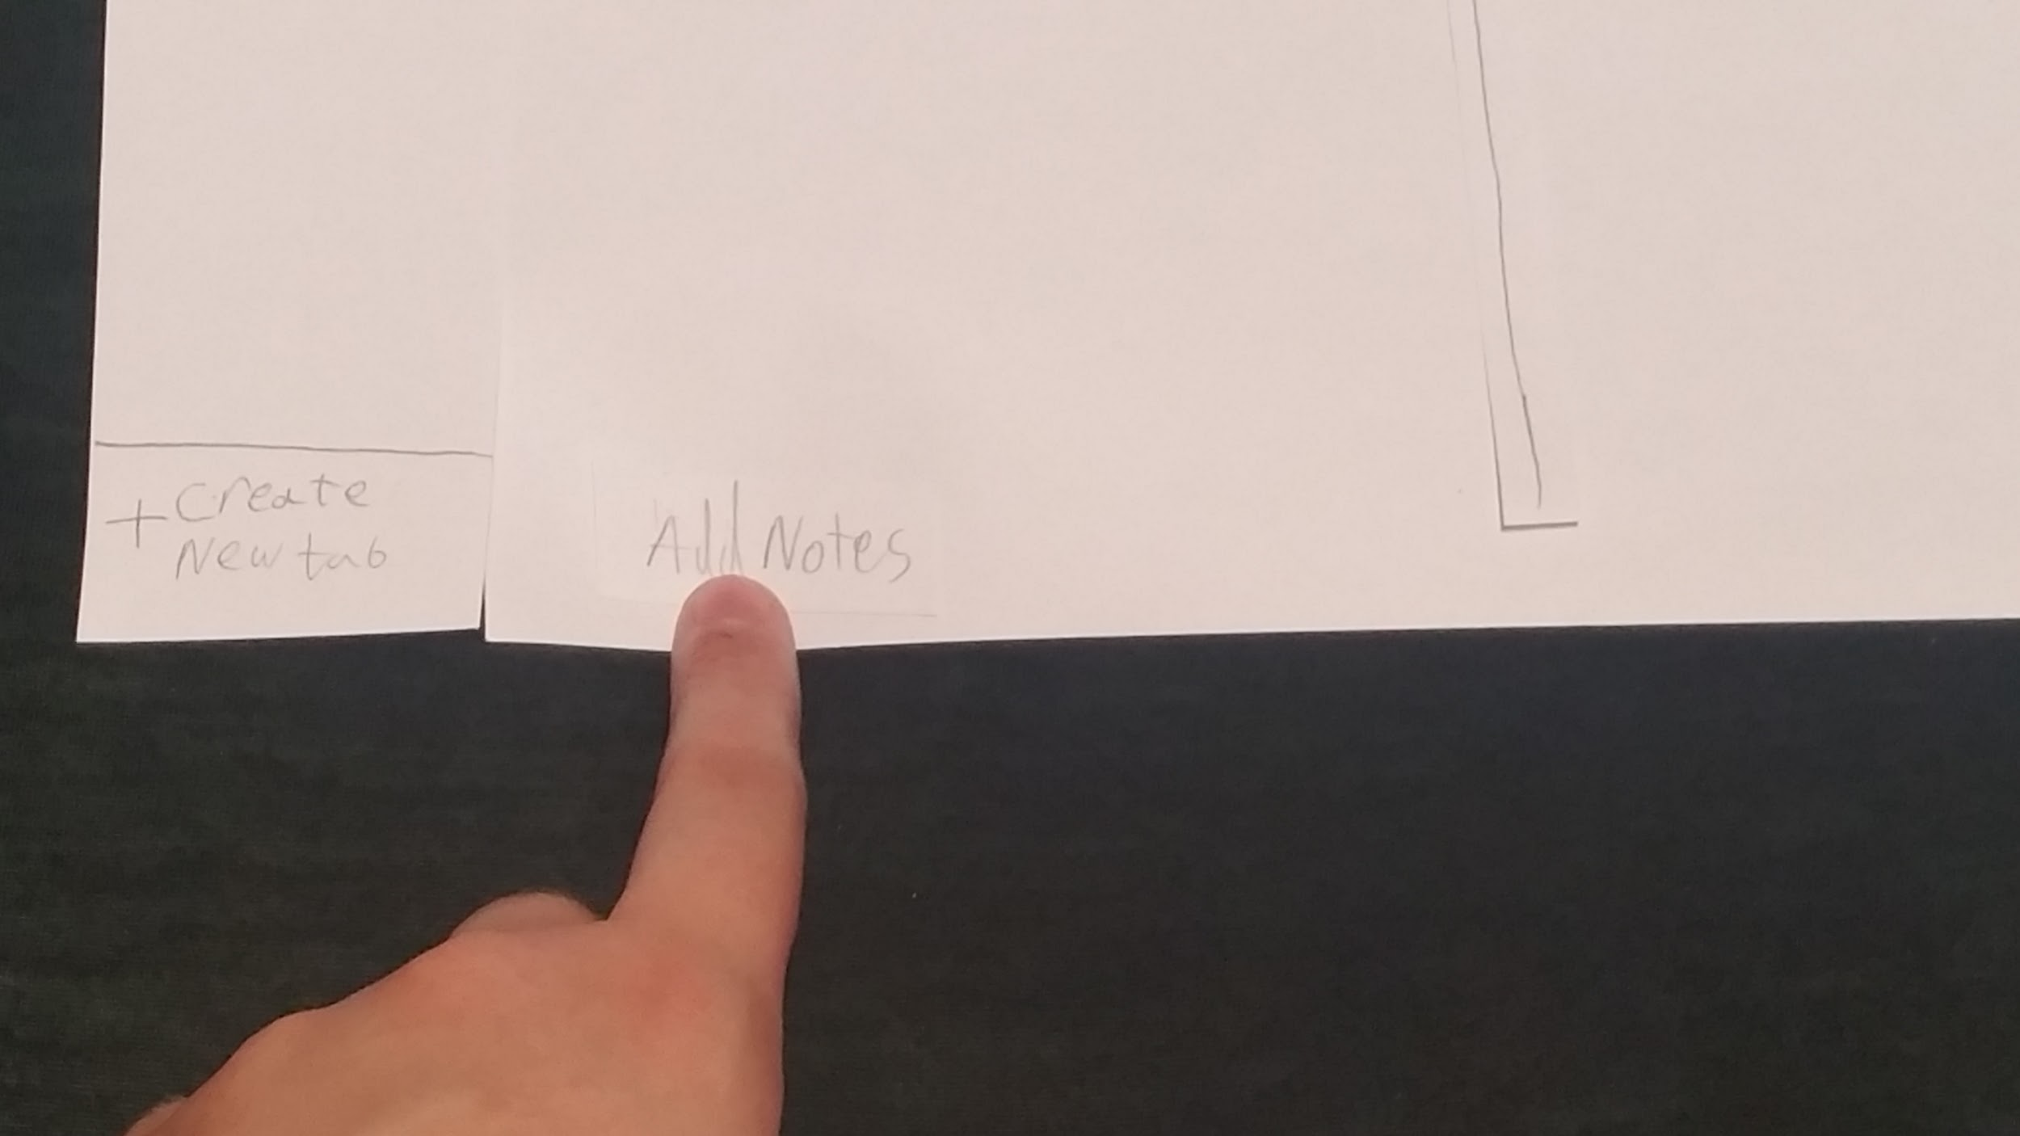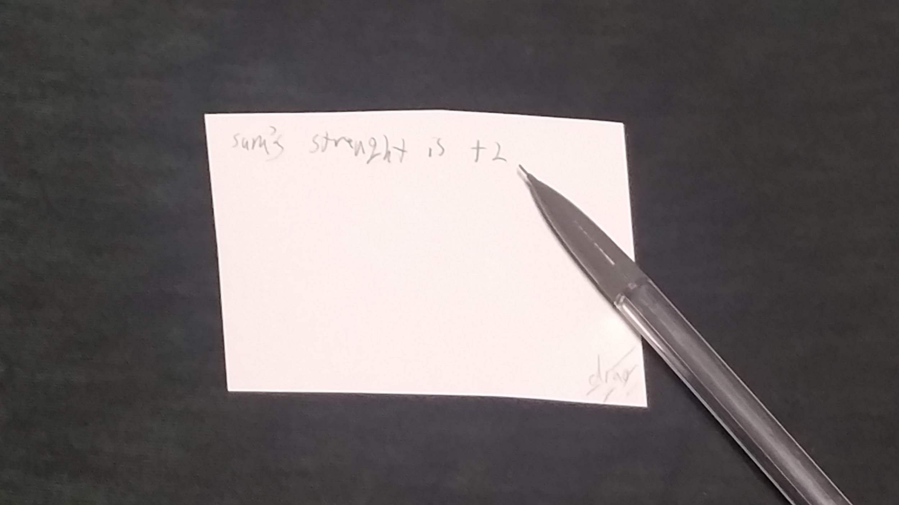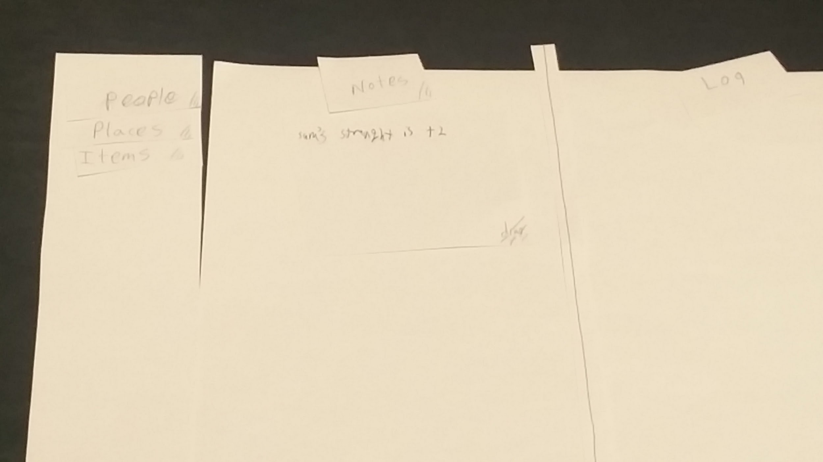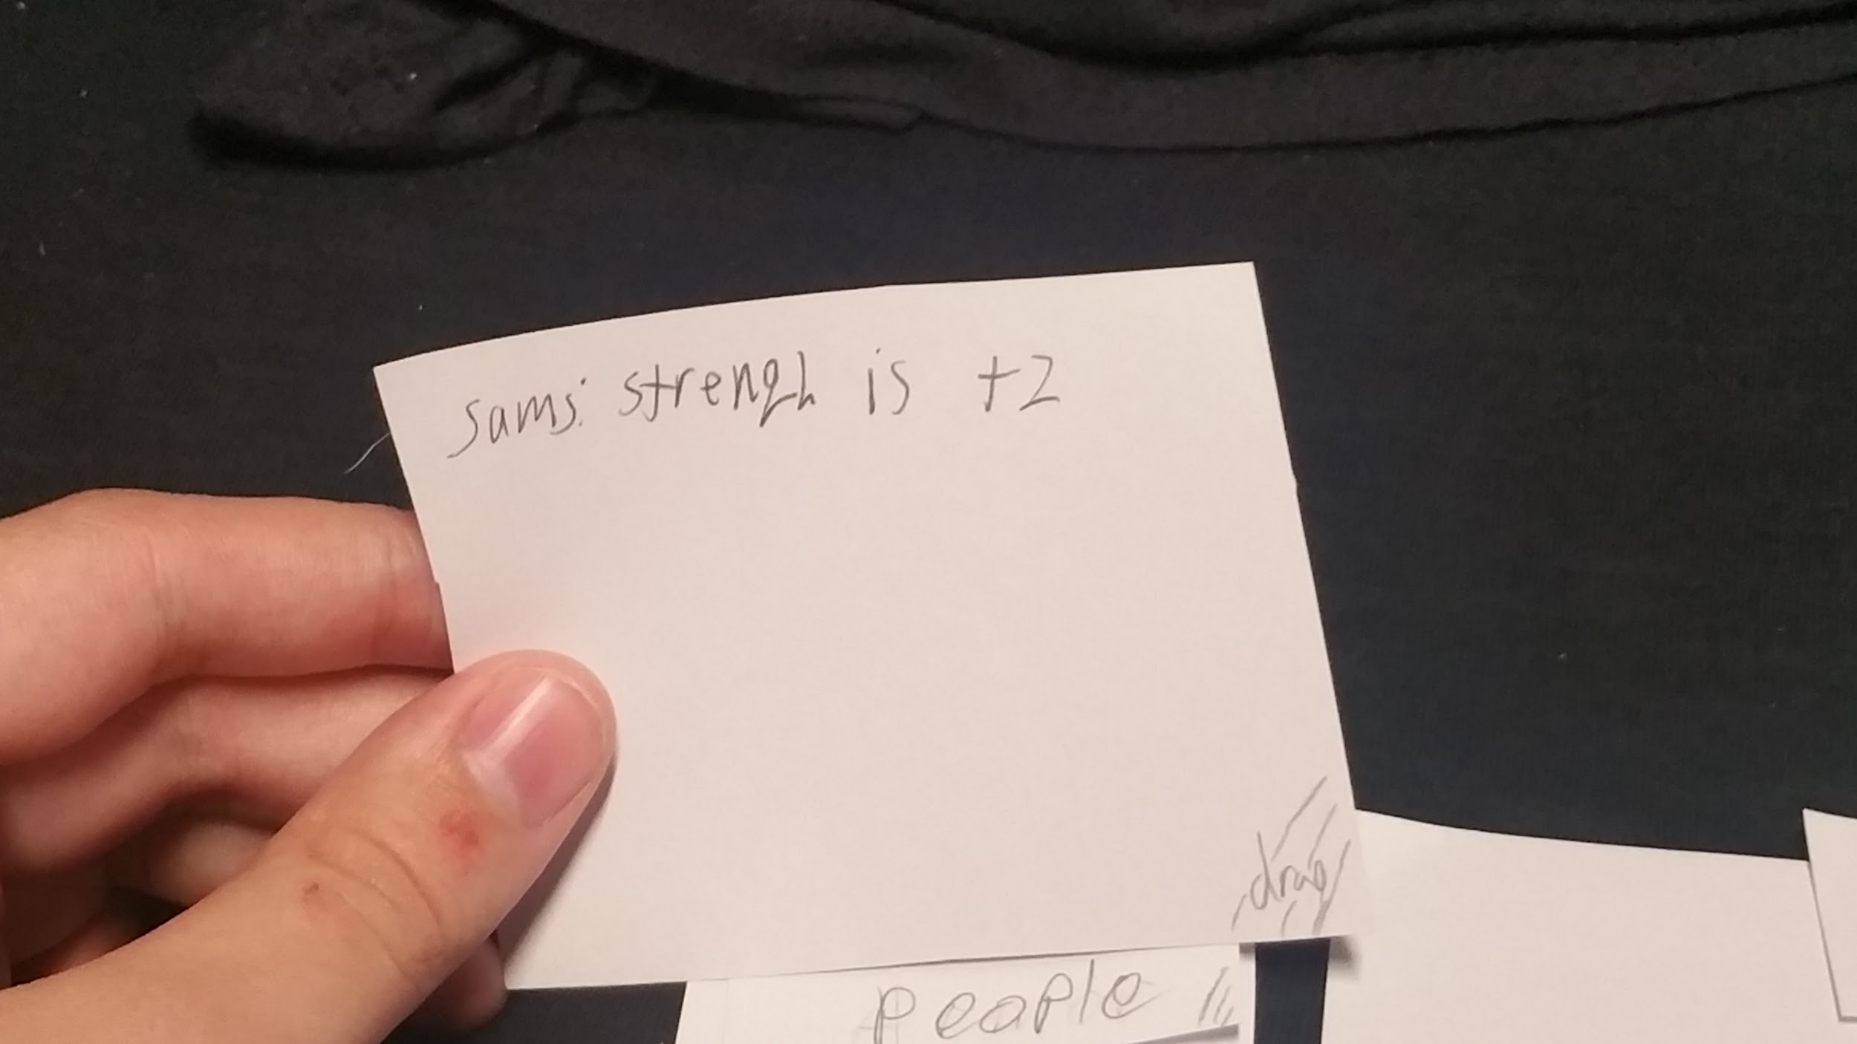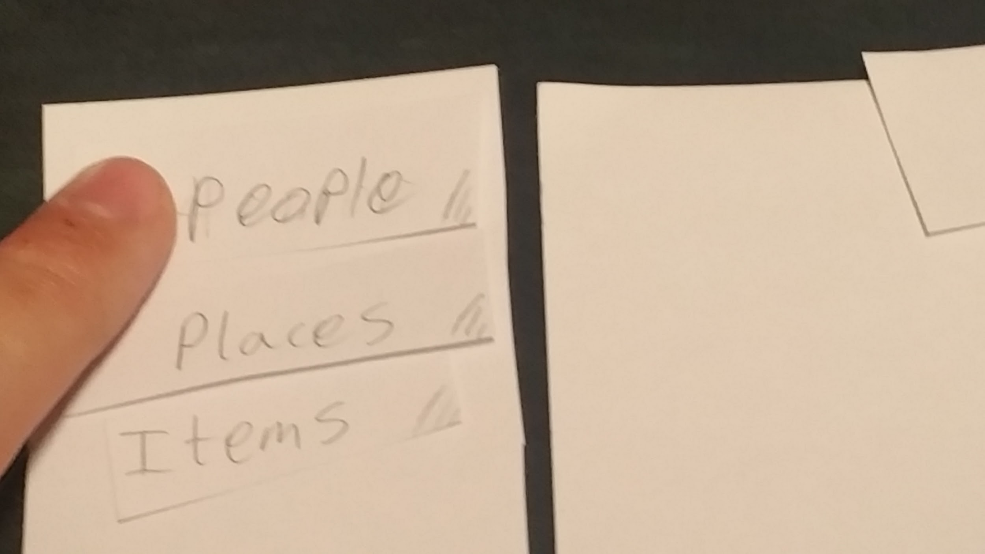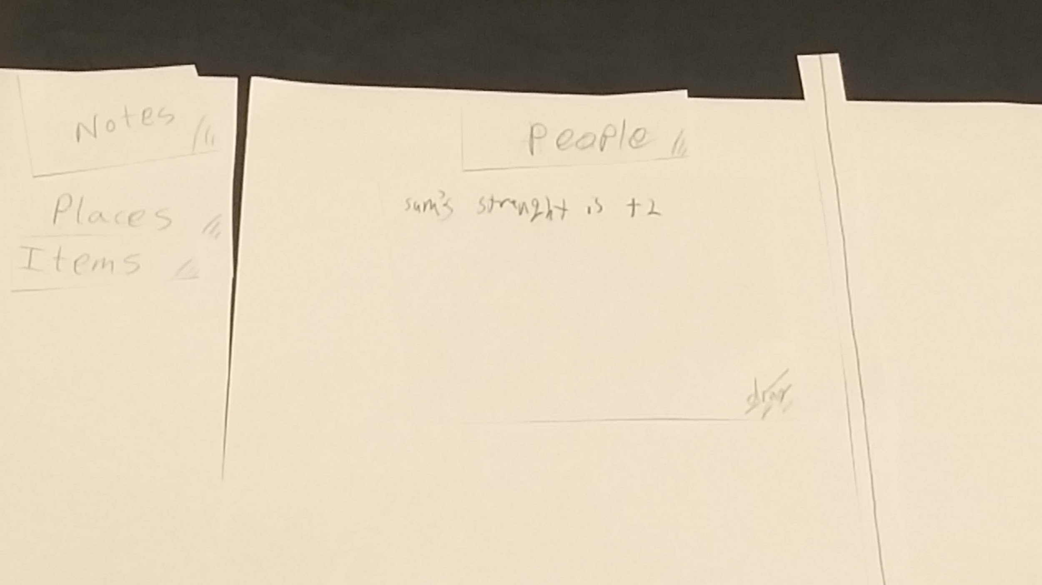

**Task 2: Flag an element from Log as important and store it**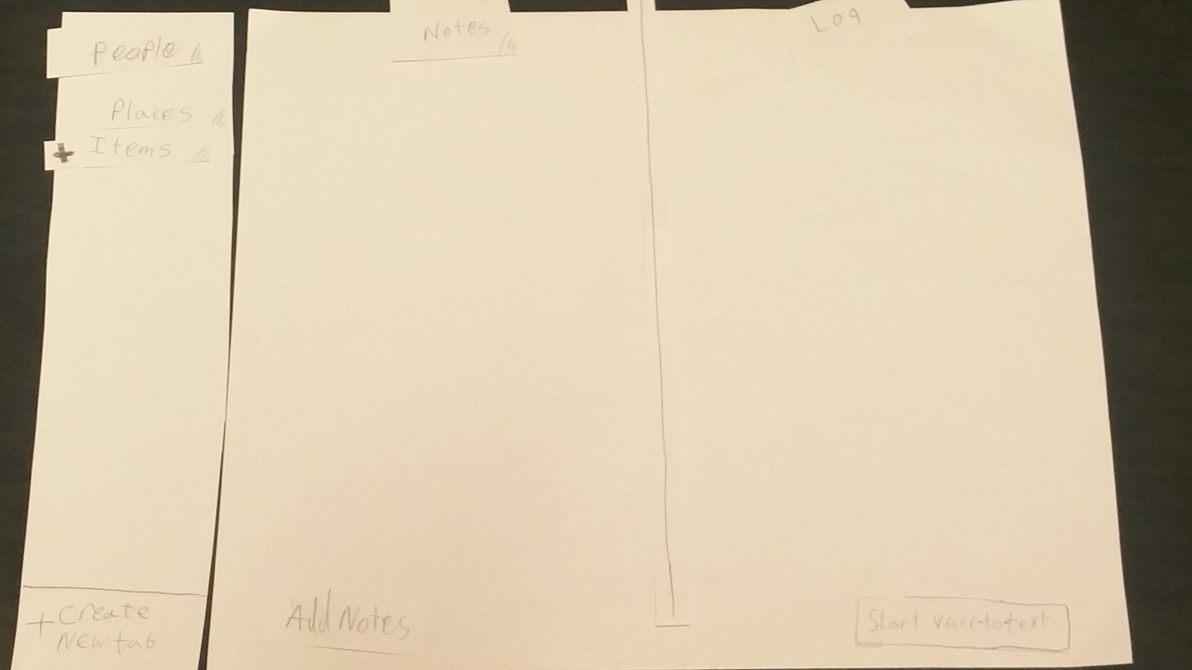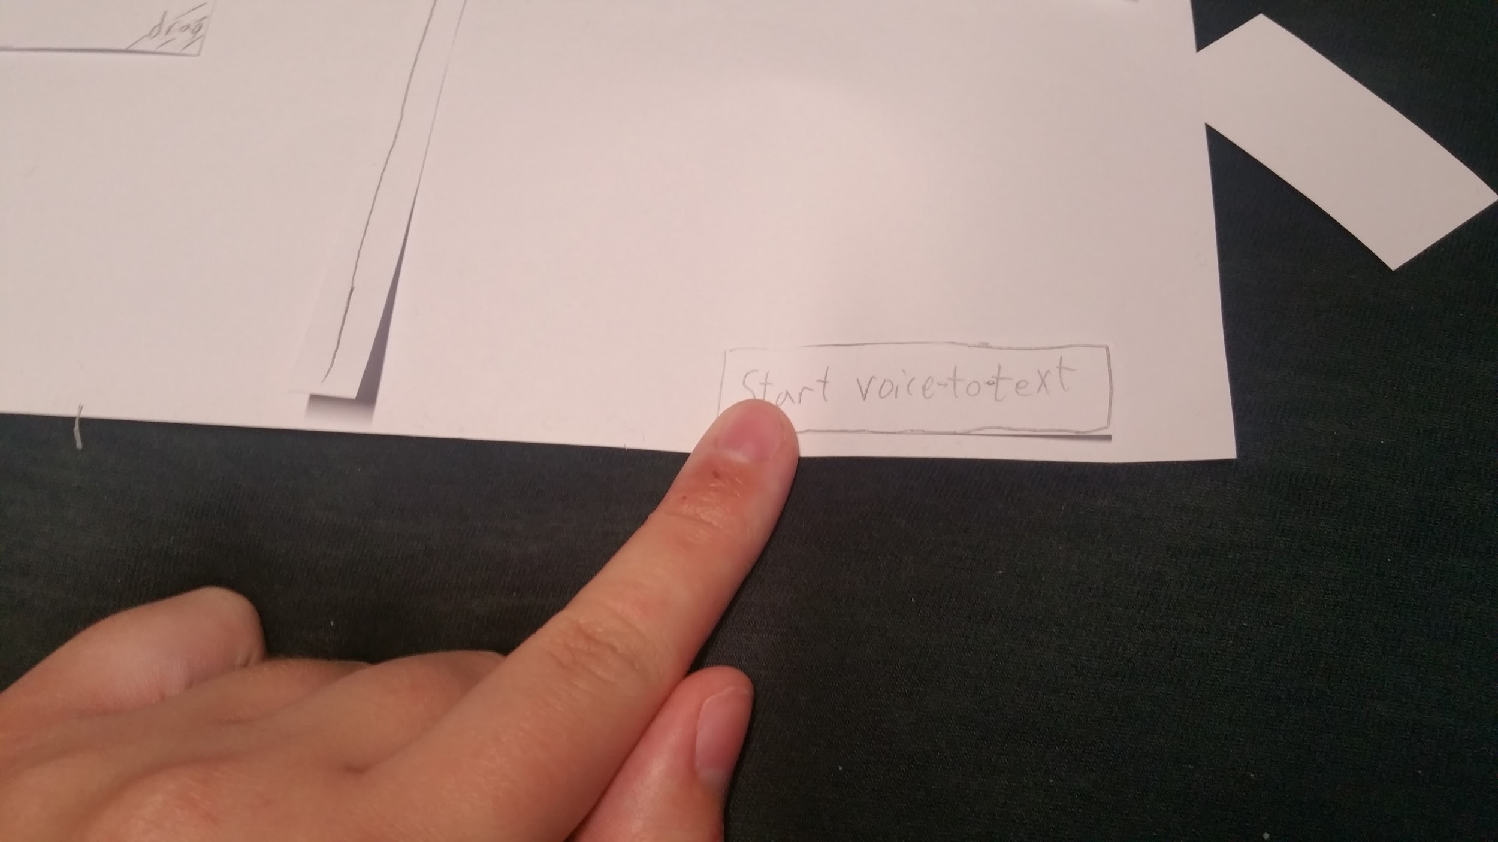

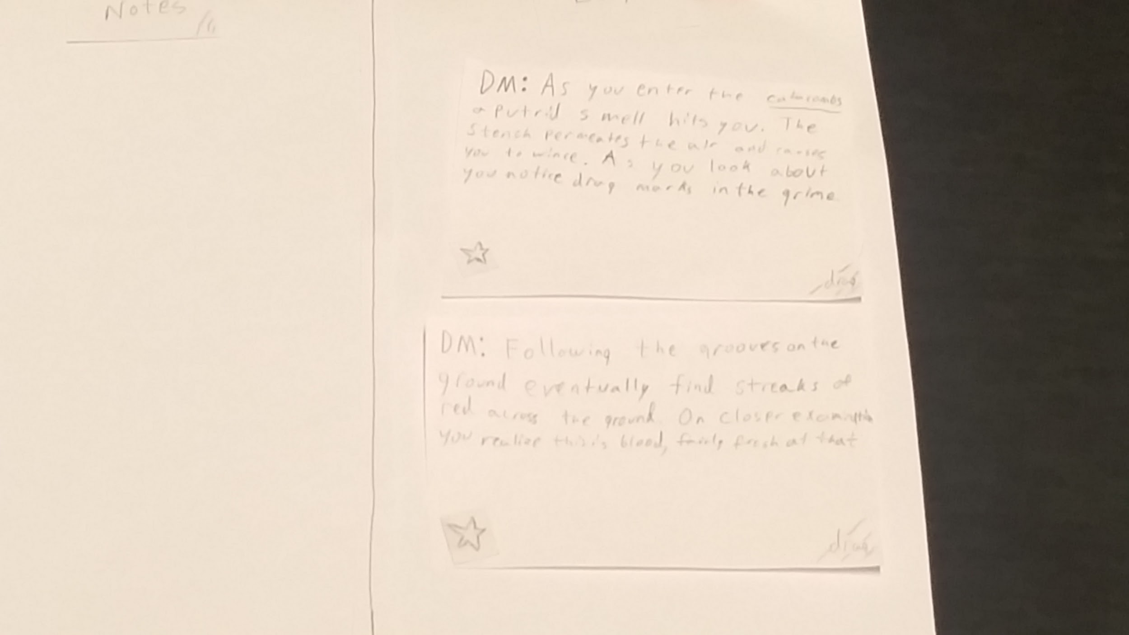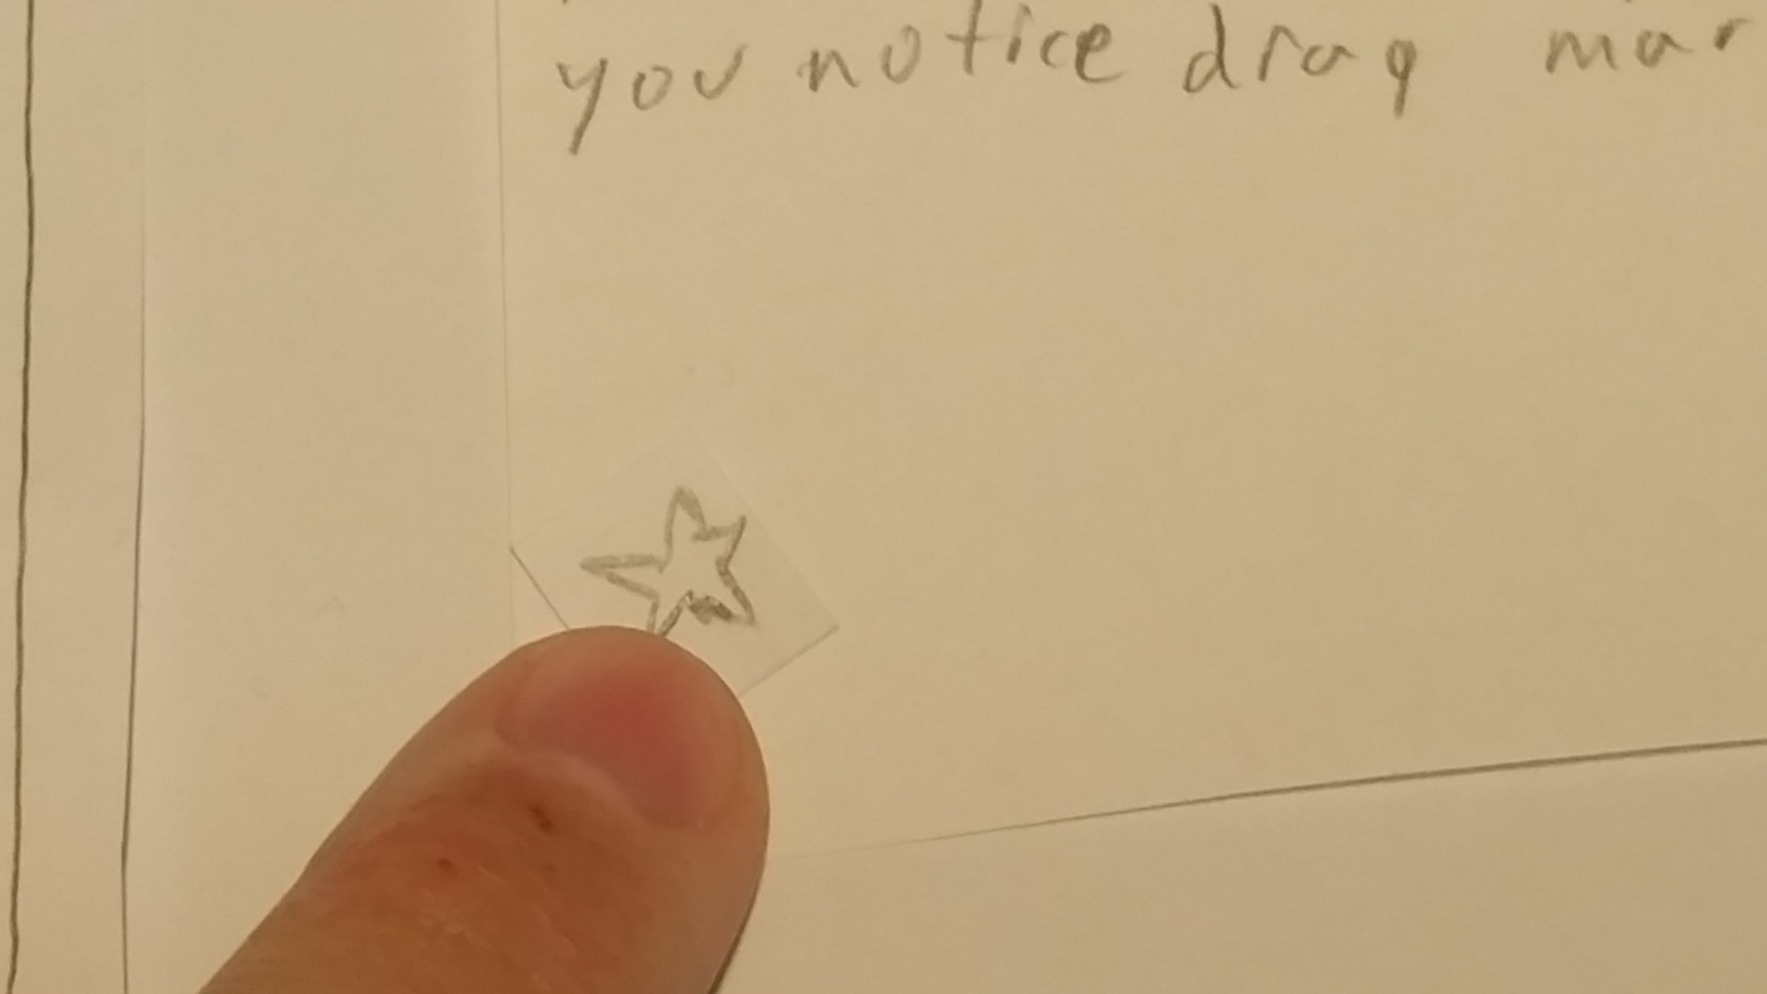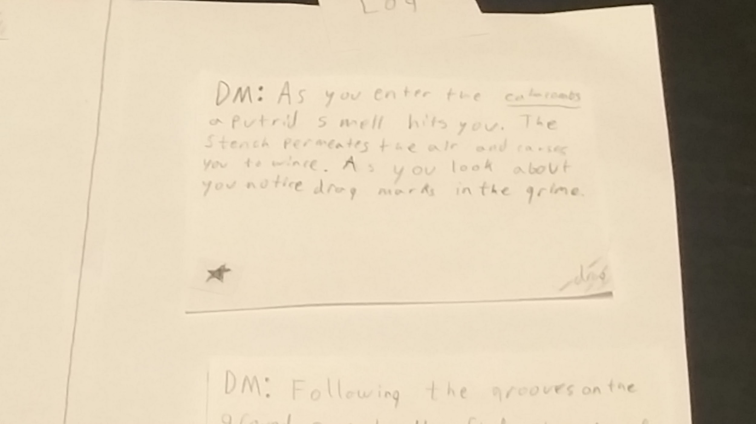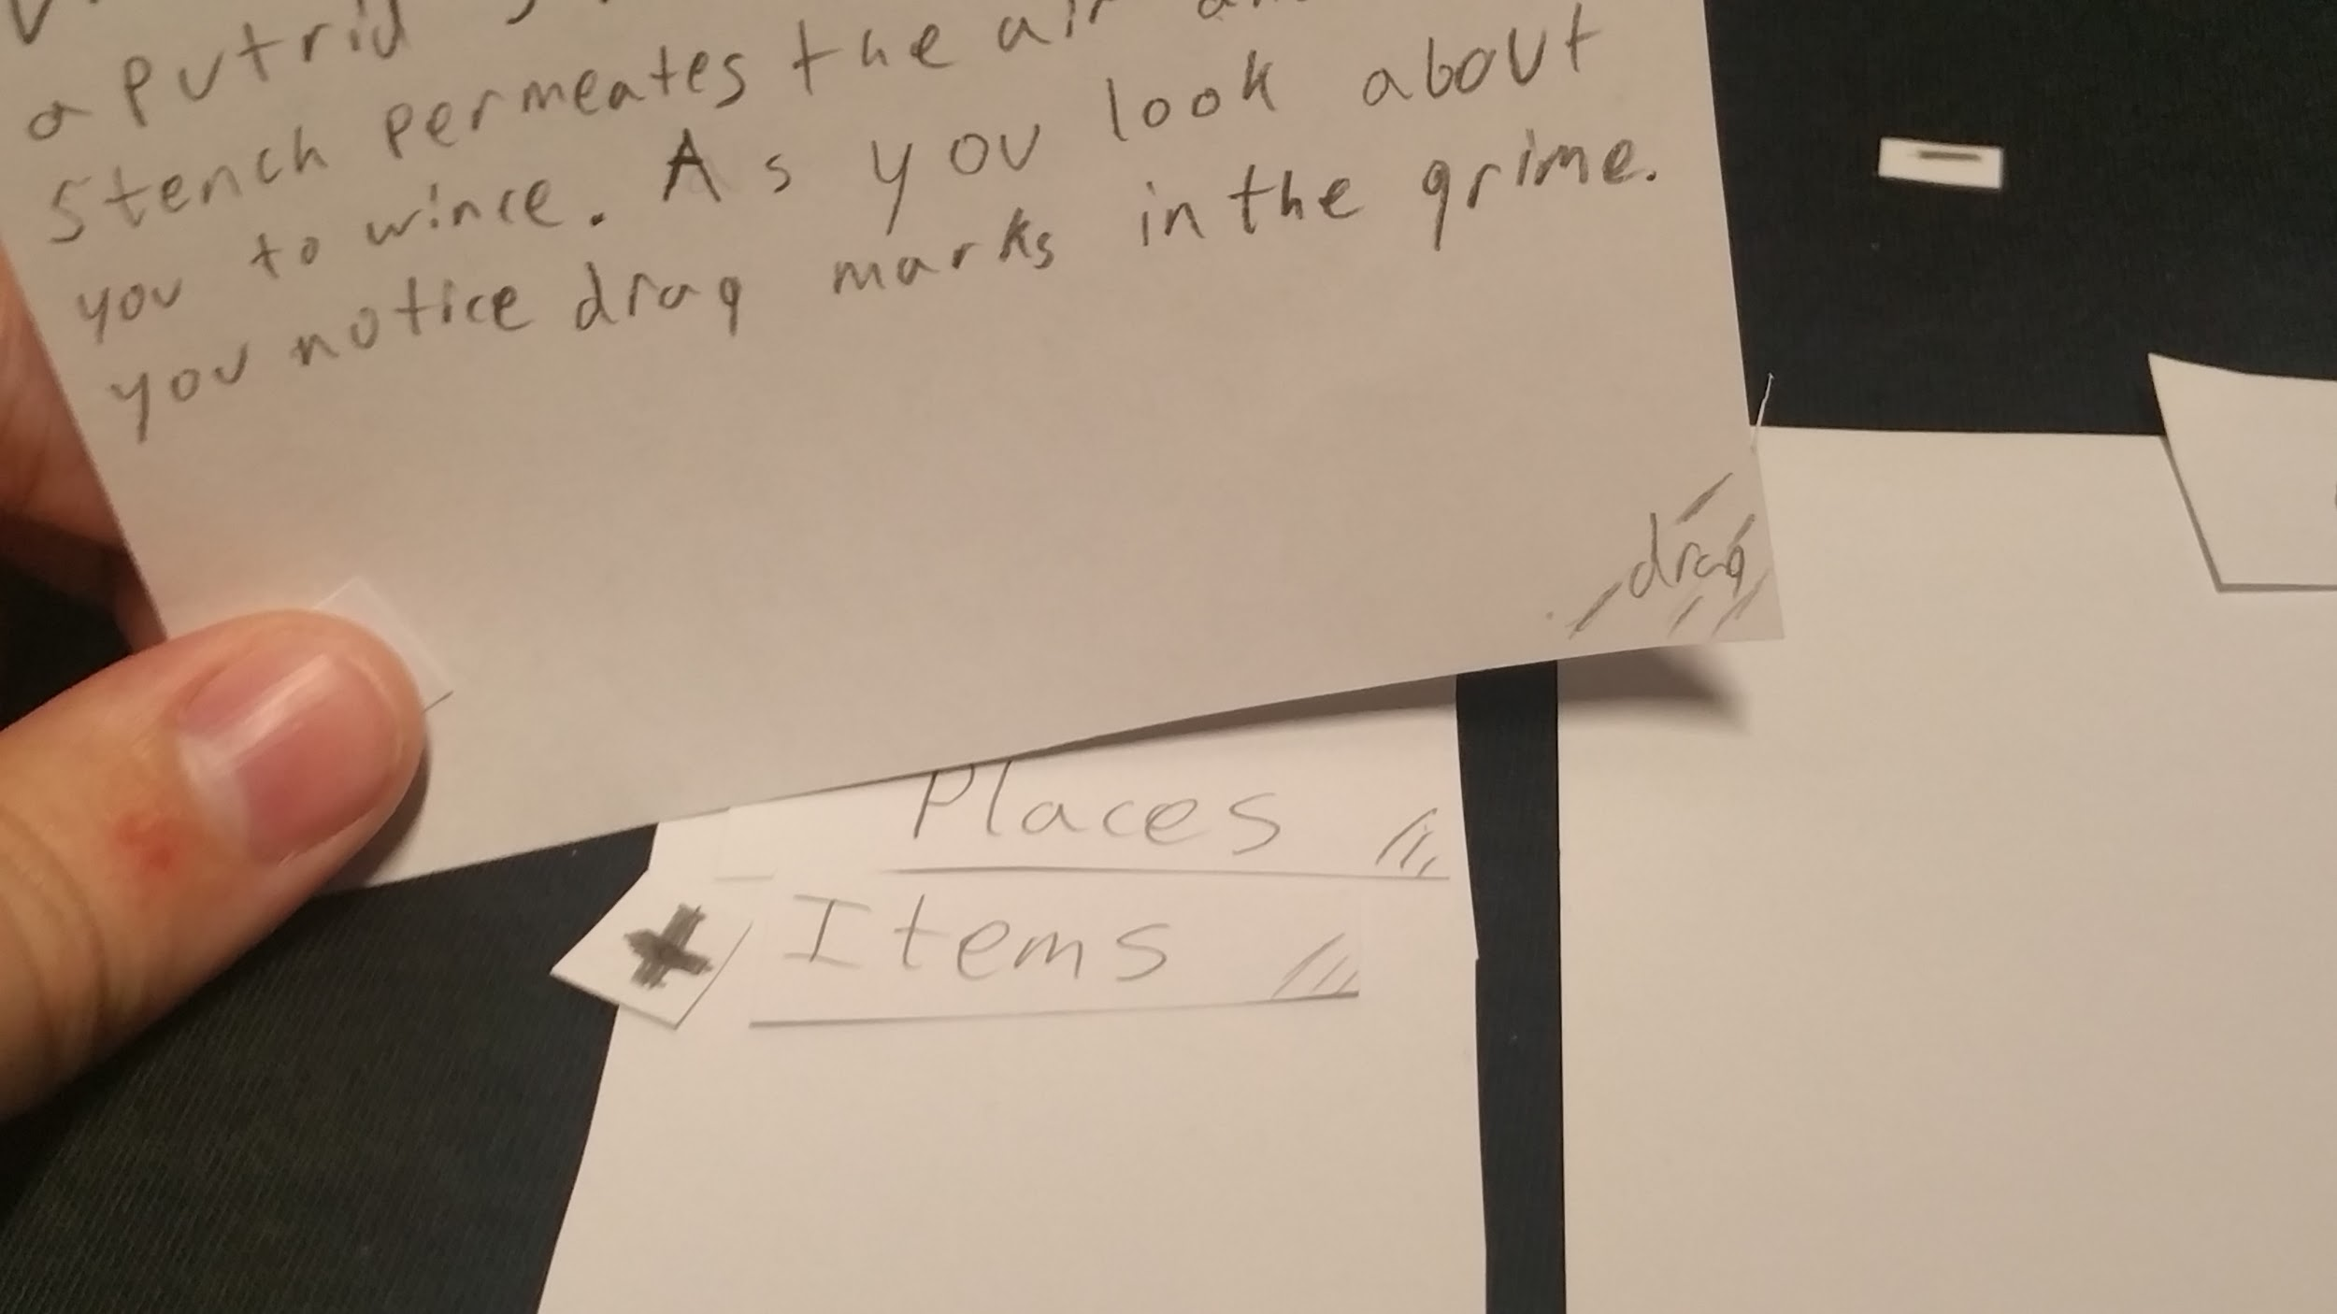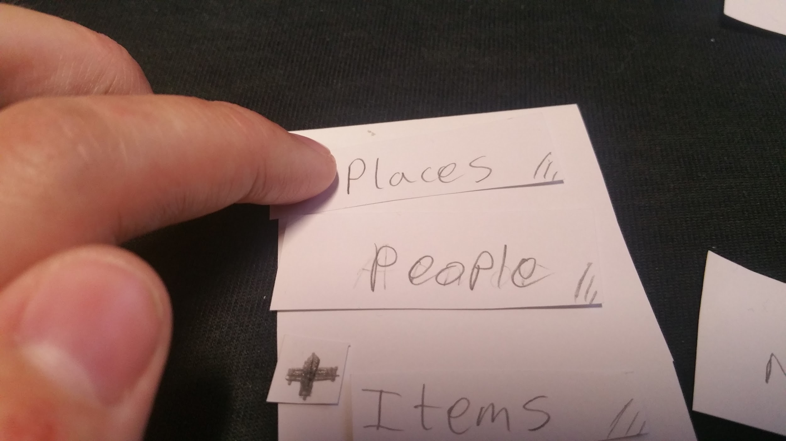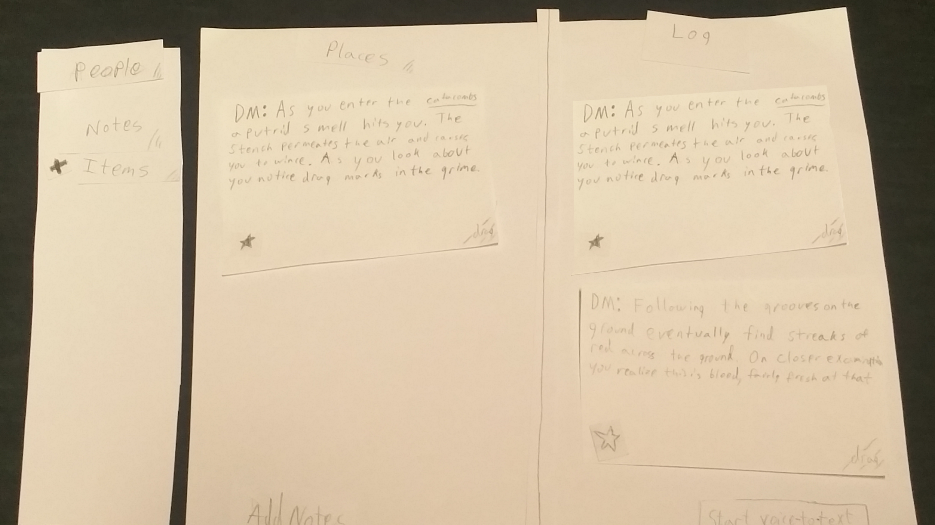

**8. Digital Mockup**

**Tasks**

**Task 1: Create a new note, and sort it into an existing tab.**

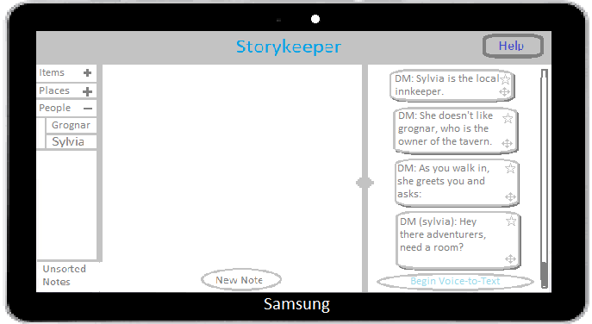

This is the opening page, showing the current game text on the right screen, unsorted notes tab in the middle screen, and tabs on the left. When the user taps on the New Note button in the Notes tab, it will start letting them type a new note. One thing we added since the beginning was the help page, for if someone got stuck.

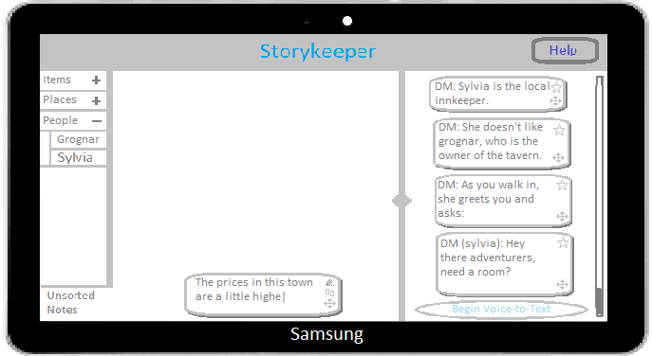

Once the user presses enter, the note they are writing becomes a bubble inside the currently opened tab. It goes below any existing text bubbles, creating a scroll bar if necessary.

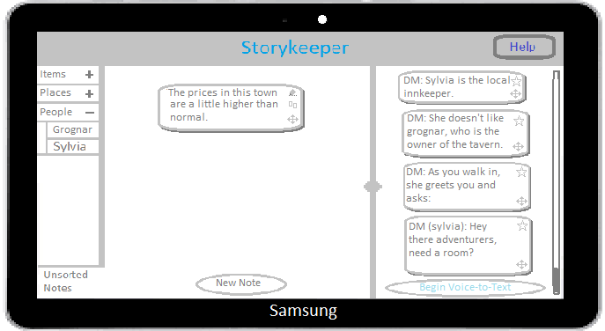

The + next to some tabs means they contain sub-tabs, and tapping on it will show them. It used to be a triangle, but people were confused at what it meant. A user can create a new tab by double tapping a tab, or empty space in tab bar, and it will create a new tab/subtab.

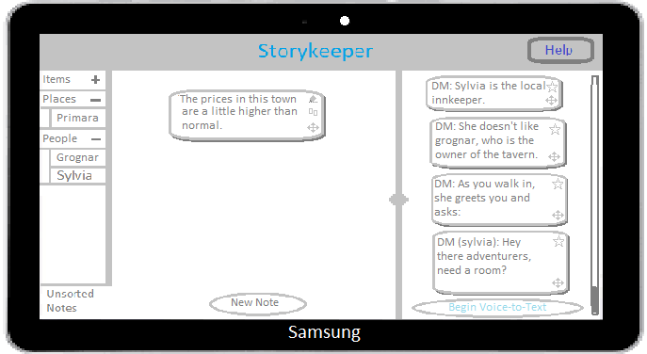

Now that the user sees the tab they want to move the note into, they just drag the note over the tab button, and it will move the note into the tab. Once moved, the note will disappear into the tab, showing it is there now. Tapping on the tab will make the middle screen show all notes within that tab.

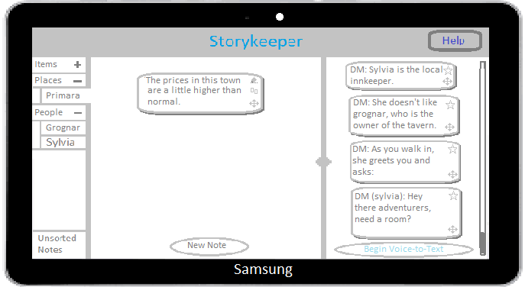

**Task 2: Move something said by the DM into an existing tab.**

The user can also take text bubbles from the DM’s voice to text and sort them into the tabs same as a note they make themselves. Back on the home screen they see the DM has spoken about Sylvia, some new information they might want. We changed the Voice to Text button from just R with sound waves because some people got confused.

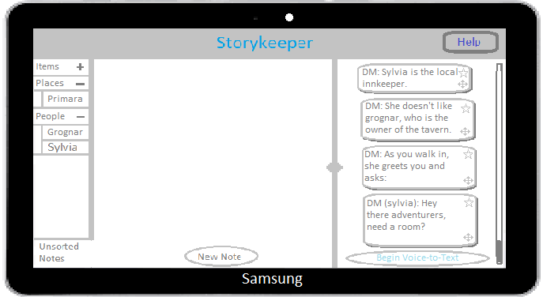

The user opens the Sylvia tab under People in the middle screen by tapping on the tab on the left.

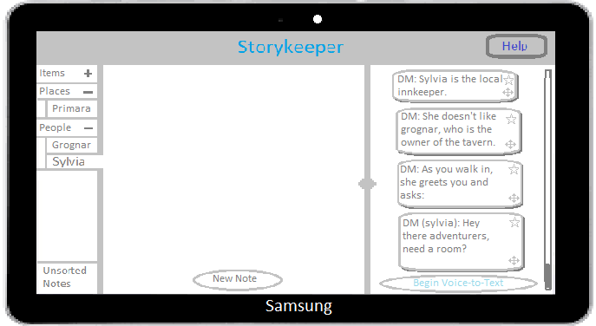

The user then moves the bubble from the right screen into the notes for Sylvia. The bubble remains on the right, since this is a shared view.

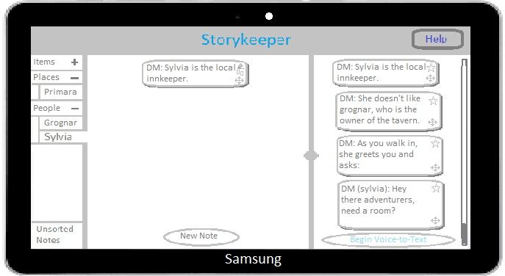

**9. Discussion:**

**Discussion**

**What did you learn from the process of iterative design?**

The process really demonstrated the benefits of giving the project another pass. After every test we found things wrong with the project, which we fixed to our best ability, and as soon as we ran another test we found more issues. The issues became smaller issues as we progressed, but each pass improved the design noticeably. In addition to this, we got to see what assumptions we made didn’t work and what assumptions did work.

**How did the process shape your final design?**

Because of the process our design became sleeker and had less moving parts. Keeping the design as simple as possible made the design easier to understand. Most of the places where our design broke down were in how the pieces interacted together and it became clear as we progressed that once the content of the design was understandable, the interactions of the design needed to be understandable. In the end the process help shape our design into something much more competent because it was much more readable than the initial design and each iteration removed some of the more confusing qualities.

**How have your tasks changed as a result of your usability tests?**

Our tasks immediately changed because we realized that you could complete any task we put forward by creating a note and putting it in a tab. That kind of interaction did not tell us anything important about our design outside of the fact people could take notes and then drag them to a tab. We started specifying the 2nd task not be allowed the note taking section at all and we also specified that we would like them to view the note (which resulted in some confusion if they forgot that portion of the task, which was its own issue). Over the course of our testing the specificity of the tasks increased. Finding the proper balance between getting them to do what we wanted them to do and not giving away too much information about what to do was difficult to strike.

**Do you think you could have used more, or fewer, iterations upon your design?**

I think that most any design could use more iterations, ours included. For the schedule and what is possible in a semester I think our iterations were enough to demonstrate how the process works. Outside of class requirements the design would have benefited from another iteration or two. Our final design included is massively improved from what we started with, but there was still some confusion about operation of the application as well as the terminology. We may have only found minor issues if we continued iterating, but we would have still made the final design just a bit better had we continued.